

**How does the home of the artist Afia Zakaria represent gender, ethnic, and political discrimination?**

Ofra Seri

**Table of contents**

**Introduction ………………………………………………………………………. 3**

### Chapter One – Yemenite Jews…………………………………………….. 6

Yemenite Jews

Operation Magic Carpet

Luwad

Ethiopian Influences

Yemenite Women Immigrants

Yemenite Immigrants in the Village of Al-Bassa

Palestinian Arab Influences

### Chapter Two – The Art of Afia…………………………………………… 10

Art as a Human Necessity

Yemenite Embroidery Art

Jewish Ornamentation

Graffiti

### Chapter Three – Literacy and Identity……………………………………. 15

Hebraization

Illiteracy

Illiteracy Among Women

Signing with a Fingerprint

Women in Art

Outsiders in Art

### Chapter Four – Discussion………………………………………………… 20

**How Does the Home of the Artist Afia Zakaria Represent Gender, Ethnic, and Political Discrimination?**

### Chapter Five – Makeup as a Means of Expression………..……………… 23

Analysis of Home-Based Artworks

Dolls and Portraits on Cardboard

**Summary……………………………………………………………………………. 25**

**Bibliography………..………………………………………………………………. 27**

**Appendices………………………………………………………………………….. 28**

Interviews

Photographs of Afia

### Introduction

Among the winding alleys of Acre’s market, between the spice stalls and the scent of fresh fish, moved the figure of Afia Zakaria. A petite woman, adorned with traditional jewelry and wrapped in a colorful headscarf, she walked quietly yet with confidence. Her black boots tapped against the ancient stones, while her hands brushed over fabric remnants, beads, and small objects—seemingly insignificant to others, but to Afia, they were fragments of memory, pieces of a vanished world[1].

The market vendors knew her well. Ahmad Mansour[2], a stall owner, recalled her as a quiet woman, fluent in Arabic, blending so naturally into the surroundings that he sometimes wondered whether she was Jewish or Arab. "She felt at home here," he said. "She never asked for much, never made a fuss. She knew exactly what she was looking for." Hussein, the fish vendor, smiled as he remembered her: "She always greeted me warmly. She was so small, always close to her shopping cart. Sometimes I worried for her—she wore so much jewelry, as if she feared nothing."

Between her wanderings in the market, the objects she collected, and the memories she carried, Afia's art was born. For years, she fought to preserve her world—not just in memory, but through paint and her own hands. This is the story of Afia Zakaria, later known as Ofra Zakaria, born in the village of Lauda, Yemen, to the Ahwal family. She was the only daughter among three brothers, cherished and pampered. Her father, a silversmith, crafted unique silver jewelry for her and brought her fine fabrics from merchants he knew, nurturing in her an early affinity for aesthetics and art. In Yemen, she would often paint in the homes of the local sultan.

Afia married Yehia Zakaria from the village of Bida, where they had six children: Kudra, Miriam, Ruda, Shalom, Zadok, and Shemariah. They also had a special daughter named Sa’ud, who passed away at the age of 15. Afia recounted that Sa’ud had foretold her own passing, earning her the name "the prophetess."

Afia deeply loved her life in Yemen. She and her husband lived in a spacious clay house filled with warmth and love. But in 1948, the family left behind their familiar world and immigrated to Israel. Initially, they were housed in a transit camp in Rosh HaAyin before being relocated to the abandoned Arab village of Al-Bassa in the western Galilee. The village reminded Afia of Yemen, and she cared for her new home with devotion—painting the floors green, tending to the almond groves, and ensuring everything was well-kept and inviting. Their home even had a traditional clay oven (tabun), used for baking and heating, a custom she had brought from her homeland.

Afia's family described her as a meticulous, elegant woman and a devoted mother who raised her children with modesty and love. But life was not always kind to her. One day, during a car ride, she suffered a severe injury—she suspected hostility from the driver, and in an attempt to escape the moving vehicle, she was burned by the exhaust pipe, which left serious scars on her face and caused her hair to burn. From that moment on, she began using makeup and drawing on her eyebrows.

The passing years brought further hardships. Her family was forced to leave Al-Bassa and relocate to the town of Shlomi. During that time, her husband Yehia passed away while hospitalized. Her married daughters moved to Nes Tziona and Rosh HaAyin, while her sons remained in Shlomi. Afia wandered between homes until she was eventually placed in a small housing apartment. There, the Yemeni-speaking woman became a stranger in her own surroundings—her neighbors did not understand her language, regarding her with suspicion and prejudice.

Yet Afia found solace in her own world. She frequently traveled to Acre’s market, where she felt warmth and familiarity with the Arab vendors from whom she bought spices, makeup, and perfumes—especially from Estée Lauder, a name that reminded her of her birthplace, Lauda. Among the scents and colors, she was transported back to her memories.

At the age of eighty, overcome with longing for her past, she returned to painting. At a local Tambour hardware store, she purchased industrial paints—red, green, yellow, blue, white, and black—meant for car repairs. She then transformed her home into a limitless canvas, painting on every surface imaginable: walls, window frames, shutters, kitchen cabinets, and even the bathroom. With endless patience, she decorated each corner with ornamental patterns reminiscent of embroidery. Her house became an infinite tapestry, echoing a distant and enchanting world.

One day, while attempting to paint a final section of the ceiling, she fell and was injured. She was treated and released home, but the injury left her unable to stand and paint. Instead, she found a new way to express her creativity—she decorated dolls in her own likeness, sculpted roosters, and drew with soot on pieces of cardboard collected from the market.

Ten years later, she wished to move in with her daughter Ruda in Nes Tziona. In 2002, Afia Zakaria passed away. Her home became a cultural landmark. The Ministry of Culture and Yad Ben-Zvi initiated efforts to preserve her wall paintings, and the Association for the Advancement of Yemenite Culture purchased the house from the Municipality of Shlomi, aiming to turn it into an official museum and visitor center. Thus, Afia’s art and legacy continue to resonate, telling the story of a woman who never abandoned her artistic spirit, even as life imposed countless challenges upon her.

For those who observe her home closely, an almost primal, mystical experience awaits. On her furniture, one finds collages of her self-portraits—charcoal sketches in black and red on cardboard—alongside handcrafted dolls, adorned with intricate embroidery and fabric appliqué, transformed into her likeness. Afia herself was a striking and extraordinary figure, keeping her artwork private for many years.

In this study, I seek to demonstrate that walls do indeed speak—that Afia’s home was, above all else, her home, not merely a painted house. Her home tells her story through the layers of paint and self-portraits. Afia, born in Yemen, arrived in Israel facing linguistic, cultural, and traditional barriers, experiencing both gender-based and ethnic discrimination at the hands of an establishment that appropriated her physical treasures throughout her life. Only after her passing did the same establishment discover the true value of her artistic legacy, while overlooking her unique identity, traditional world, and the deeper messages embedded within her creations.

This research will focus on the historical, social, and artistic dimensions that led Afia to develop her autodidactic artistic practice. Additionally, it will incorporate interviews and encounters with her family, providing a close examination of her personal archives. On an academic level, I will contribute a professional perspective based on my experience as a researcher of Afia Zakaria, since joining the preservation team at Yad Ben-Zvi.

## Chapter 1: Religious, Ethnic, Traditional, and Cultural Influences

**Yemenite Jews**

The exile and Jewish settlement in Yemen began with the destruction of the First Temple in 422 BCE[3]. By the 19th century, approximately fifty thousand Jews resided in Yemen, living in various Jewish communities in villages and cities across the country. While Muslim Yemenites were primarily farmers and shepherds, Jews were permitted to engage in complementary trades, commerce, and various crafts such as blacksmithing, leather-working, tin-smithing, construction, carpentry, embroidery, jewelry making, weaving, and basketry[4].

Jews were considered dhimmis (protected but second-class citizens) under Muslim rule. Their relationship with the Muslim population fluctuated, often deteriorating during times of political unrest in Yemen. Jewish communities suffered from social inferiority, and in many places, they were denied fundamental rights, including protection from verbal and physical violence[5].

Despite these hardships, the Jewish community in Yemen maintained connections with other Jewish centers worldwide. Throughout history, Yemenite Jews corresponded with Jewish leaders in the Land of Israel, Babylonia, Spain, and Egypt, allowing them to stay updated with the latest scholarly writings and philosophical developments. Individual Yemenite Jews continuously immigrated to the Land of Israel, despite the arduous and perilous journey. The first large group migration occurred in the 1880s, followed by another wave in 1906[6], when about 3,000 Jews arrived. The largest group migration took place in 1949, with approximately 50,000 Jews making aliyah.

**Operation On Wings of Eagles (1949)**

Operation "On Wings of Eagles" was the codename for the airlift of Yemenite and Adenite Jews to Israel as part of the mass Jewish immigration efforts in 1949 and 1950. The operation was named after a verse from Exodus 19:4: "And I bore you on eagles' wings and brought you to Myself." It was also known as "Operation Magic Carpet" and "Operation the Coming of the Messiah."

Political changes significantly influenced Jewish emigration from Yemen, accelerating it during Ottoman rule, slowing it during the British Mandate, and intensifying it after the establishment of the State of Israel. Factors pushing Jews out of Yemen included political events, military conflicts, natural disasters, and economic instability that undermined traditional livelihoods. In contrast, positive factors included religious aspirations and the presence of an established Yemenite community in Israel, which encouraged relatives to join them. Reports of improved living conditions, modern advancements, and political developments in Israel reached Yemen, further strengthening the desire to immigrate. Additionally, Jews in Yemen, as dhimmis, sought the freedoms and civil rights available in Israel, motivating them to leave.

The migration peaked in 1948 following the assassination of Imam Yahya, whom the Jews viewed as their protector. Fearing for their safety, Yemenite Jews sought to leave, and the newly appointed Imam Ahmad granted official exit permits, leading to a mass exodus. The State of Israel, in collaboration with Jewish organizations and with British consent, organized the airlift of Yemenite Jews. Between 1949 and 1950, the long-standing Jewish migration movement from Yemen, which had begun in the late 19th century, reached its climax, effectively ending the Jewish presence in Yemen.

**Loder: A Town in the Kawkaban Region, Southeastern Yemen**

The town of Loder, located in this region, was known for its vibrant commercial and religious activities. Its strategic location along the maritime trade route from Aden, the central port city, made it a crucial hub for goods and information flowing into Yemen.

Between 1839 and 1937, Aden was a British-ruled province under the Raj, serving as a key port along the shipping route between the Suez Canal, India, and other Asian nations. As a coal refueling station for British ships, Aden became a major trade center and export hub for the Arabian Peninsula. Under British rule, Adenite Jews enjoyed relative equality, benefiting from economic opportunities linked to British presence and expanding global trade due to technological advancements.[7]

Aden’s port facilitated trade between India and Europe, as well as with African nations along the Red Sea, such as Ethiopia and Egypt. This geographic position influenced regional commerce significantly. Yemenite Jewish merchants in Aden and surrounding towns introduced locals to imported consumer goods such as fabrics, jewelry, spices, and utensils, primarily from India, Egypt, and Ethiopia. These imported goods carried cultural significance, reflecting local customs, social hierarchies, and aesthetic traditions. For instance, the recurrent use of red, yellow, and green—colors associated with African nations—was prominent in textiles, ornamentation, and art. Geometric patterns and motifs conveyed social status, while locally sourced spices and jewelry symbolized economic standing. These cultural influences shaped the traditional aesthetics of Yemenite artisans, impacting clothing, embroidery, and culinary practices.[8]

**Ethiopian Influences on Afia’s Art**

The combination of green, yellow, and red has held symbolic importance in Ethiopia for centuries and first appeared in the Ethiopian flag in the 19th century. Ethiopia’s unique status as an expanding African empire during European colonial incursions, its ancient history recorded in a local script, and its biblical and religious significance contributed to its symbolic power among Africans and the African diaspora[9]. The green color represents Ethiopia’s fertile land, yellow symbolizes Saint Peter’s halo in Christian tradition, and red signifies the Ethiopian Empire’s strength and faith.

These colors prominently feature in Afia’s artwork and character. Given that her father was a fabric trader and her community’s proximity to Ethiopian trade goods, it is likely that these influences were ingrained in her artistic expression and later surfaced in her mature work.

**Yemenite Women Immigrants After the Establishment of Israel (1949)**

The integration of Yemenite women into Israeli society was challenging. Their cultural differences, traditional attire, and lack of technological literacy caused significant difficulties. Linguistically, they spoke only rudimentary Hebrew, primarily biblical phrases, and most were illiterate. Their arrival in Israel, where they encountered diverse immigrant populations, led to social alienation and rejection by native-born Israelis[10].

Culturally, their families and communities were patriarchal and conservative. In Yemen, the family and social structures adhered to deeply rooted traditions, with men as the undisputed heads of households. Women were prohibited from conversing privately or publicly with unrelated men. Upon immigrating to Israel, these women often felt confused and embarrassed when faced with mixed-gender interactions in both private and public settings[11].

Professionally, Yemenite women in their homeland engaged in weaving, embroidery, and basketry[12]. However, in Israel, demand for such crafts was low, and they were employed primarily as domestic workers or factory cleaners. This labor pattern began with the first Yemenite immigrants in 1882, who faced economic hardship and social exclusion, forcing them into menial jobs. During the Second Aliyah, Yemenite immigrants were deliberately recruited as a cheap labor force under the Zionist movement’s policies. Consequently, cleaning became an occupation strongly associated with Yemenite women[13], persisting well into the early years of the state.

**Yemenite Immigrants in Al-Bassa**

Al-Bassa was a large Arab village in the western Galilee, near the Lebanese border. Under the British Mandate, it belonged to the Acre district. During the 1948 war, the village was captured, and its inhabitants fled to Lebanon. The Arab Revolt and the al-Bassa Incident

The Arab Revolt (1936–1939) marked a major turning point in the relationship between the Arab population in Palestine and the British Mandate authorities. During the revolt, the British carried out a range of military and administrative actions aimed at crushing the uprising actions that often-harmed civilians. These included house demolitions, collective punishment, mass arrests, and revenge operations.

The goal was to restore public order by showing military strength — a policy that historian Matthew Hughes later described as “the banality of brutality.”[14]

One of the main targets of British punishment was the village of al-Bassa, located in the northwestern Galilee near the Lebanese border. In September 1938, after a roadside bomb killed several British soldiers in the area, forces from the Royal Ulster Rifles and other armored units were sent to the village to “punish” its residents.[15]

On the morning of September 7, 1938, British troops entered al-Bassa and opened machine-gun fire on the village houses. The shooting lasted for several minutes, after which several buildings were set on fire.

A British officer, Desmond Woods, later recalled: “I will never forget arriving at al-Bassa … seeing the Rolls-Royce armoured cars peppering Bassa with machine gun fire … and then we burnt the village to the ground.”[16]

Later that day, dozens of village men were arrested and loaded onto a bus that had been rigged with explosives. The bomb detonated, killing many of them — estimates range from 20 to 50 dead.

Although the event was officially recorded as a “reprisal action,” Hughes’s later research shows it was in fact a clear example of systematic colonial repression— meant to spread fear and break popular support for the revolt.[17]

The al-Bassa incident became a symbol of the cruelty of British colonial rule and a striking example of what Hughes calls a “dirty war”— a kind of conflict where the line between fighters and civilians is erased.[18] The British policy of pacification, based on overwhelming force, created deep fear among the Arab population. It also drew international criticism and undermined the legitimacy of British control in Palestine.

Over the years, the al-Bassa event has remained a key part of Palestinian collective memory and public discussion about the legacy of colonial violence. Some organizations have even called on the British government to acknowledge the massacre as a colonial crime and formally apologize for its actions in Palestine.[19]

The events at al-Bassa show the tension between Britain’s desire to restore order and its harsh treatment of civilians. They reveal the essence of the colonial system: the use of collective punishment as a tool of control, blurring moral and legal boundaries.

In the decades that followed, al-Bassa continued to serve as a central reference point in historical research on the British Mandate and the power dynamics that shaped relations between Jews, Arabs, and the British authorities in the years before the establishment of the State of Israel.

Today, its remains lie within the municipality of Shlomi. Initially, Jewish immigrants from Eastern Europe were settled there in 1949, followed by Yemenite immigrants in 1950, who remained until 1980[20].

Life in the village is described through personal testimonies. "After the plane brought us to Israel, we were transferred to the immigrant camp in Rosh HaAyin. It wasn’t easy there. We waited an entire year for a permanent place to live… After a year, they moved us to the village of Al-Bassa in northern Israel, near Lebanon.[21] After we arrived in Israel, we were placed in the immigrant camp in Rosh HaAyin, and after six months, we were moved to a place called Al-Bassa in the Upper Galilee, which became our permanent home. There was a large shack, and they gave us an iron bed and a straw mattress, but nothing else. The tent was full of thorns, and no one cleaned it. There was only a shack, and they told us, ‘Go over there,’ and so we remained in Al-Bassa for many years. My father found work in agriculture in the area. He worked all week, and on Fridays, he would bring us delicious treats”[22]. The conditions in Al-Bassa were very harsh in both winter and summer, yet the morale was high. They knew how to live with little and without complaints; they had no demands and made do with what they were given[23].

**Arab-Palestinian Influences on Afia’s Art**

Afia Zecharia, a Yemenite-born artist, spoke only Yemeni Arabic. Her adherence to her mother tongue symbolized her unique and socially distinct identity. When she moved into an Arab home in Al-Bassa, she felt a deep sense of familiarity.She felt as if she had returned to her birthplace in Yemen, as recounted by Yehudit Zecharia, her daughter-in-law, "Afia loved the high ceiling of the stone house and would sing in Yemeni all the time, especially while cleaning and baking. She was also very happy with the herb garden, which allowed her to prepare Yemeni pastries and dishes. A tabun (a stone oven) was built for her in the center of the kitchen, where she would bake and cook."

According to her granddaughter, Rachel Havani, when Afia was forcibly relocated to an apartment in the town of Shlomi, she was effectively disconnected from the land, nature, and environment that reminded her of her childhood and youth in Yemen. However, she continued to visit the municipal market in Acre, a mixed city with an Arab majority. The Arab merchants in the market enjoyed conversing with her in their language, and she, in turn, felt comfortable communicating with them, relishing the different scents of the market—spices, perfumes, and various tools and accessories that were familiar to her from Yemen.

Afia used to travel to the market about twice a week. In January 2023, I visited the Acre market to locate the merchants who regularly served Afia. A family acquaintance, Ibtisam Al-Mawal from Acre[24], accompanied me on the tour to help locate and translate into Arabic if needed. Our first stop was a shop selling sewing supplies, hair dyes, facial products, decorative ribbons, and more.

The shopkeeper, Muhammad, was delighted to meet us and shared that when he was a young man of about 20—almost 35 years ago[25] would come to his store to buy items. They would converse in Arabic, and she would bless him and his family. Within the family, she spoke to her children in Yemen, and during wedding celebrations, such as the *henna* ceremony, she recognized the familiar symbols that connected her to her Yemeni identity.[26]

From the above, it is clear how Afia maintained her cultural uniqueness, which was also reflected in her original art—free of modern influences and remarkably and creatively tracing her Yemeni surroundings, which were shaped by Arab cultures. The recurring ornamentation in Afia's works resembles the arabesque technique characteristic of Islamic art. The arabesque is a decorative motif featuring a series of lines and shapes that repeat in a pattern, usually in geometric forms combined with individual embellishments.

The reason for the prevalence of arabesque ornamentation stems from a religious prohibition (also mentioned in Judaism) against depicting human figures, which led to an emphasis on repetitive forms, sometimes combined with Quranic verses[27]. The difference in Afia's ornamental art lies in the way she integrates her self-portrait alongside the recurring ornamentation. On the walls of her home, Afia meticulously painted ornamental patterns resembling an endless embroidery of repeating shapes, incorporating her portrait into some of them. However, whereas Islamic arabesque is displayed in public spaces, Afia's home-based creation—including her portrait—transforms her artwork into a private expression dedicated solely to herself. Her artwork, characterized by traditional ornamentation reminiscent of Islamic arabesque patterns, demonstrates the cultural fusion that shaped her artistic vision.

**Chapter 2: Afia's Art**

**Art as a Human Necessity**

Since the dawn of history, humanity has created art using various materials, driven by the desire to express emotions, hopes, a shared language, and a means of social communication. Art is an inseparable part of daily life, both practically and visually. Like language, art serves as a medium for conveying ideas that transcend linguistic barriers, existing independently and accessible to all.

The artistic process, as we recognize it today, began in prehistoric times. Thousands of years ago, early humans painted on pyramid walls and cave interiors in Western Europe. These paintings reflected daily life, customs, and culture. Later, religious and faith-based art emerged, and by the 20th century—amidst global secularization—artistic expression shifted towards personal and social commentary, liberated from traditional constraints.

Throughout history, painting has been practiced by two primary groups:

**Didactic Painters** – Artists who study painting in structured settings, refining their skills through formal instruction. These painters are exposed to diverse techniques, artistic movements, and experimental methods. Early in their training, they follow strict guidelines, mastering both drawing and color application. Institutional frameworks provide academic grounding in art history to deepen their understanding of visual language. Additionally, they acquire essential artistic concepts such as composition and spatial awareness, which serve as foundational elements in their creative evolution.

**Autodidactic Painters** – Self-taught artists who develop their craft through observation and inner intuition. For these painters, the creative process is primarily emotional, and the choice of subject or style is entirely personal. Their technical skills may appear naive or non-realistic, yet their grasp of color blending and application often reveals a profound understanding. Their art serves as a form of psychological and physical healing. Some of these artists continuously refine their abilities through self-discipline and persistent practice, leading to remarkable artistic achievements. A prime example is Andy Warhol, who developed his distinctive style independently and became a central figure in the Pop Art movement. Ultimately, the professional success of both didactic and self-taught artists depends on their originality and ability to attract independent recognition.[28]

**The Art of Yemenite Embroidery**

Yemenite embroidery is an ancient and esteemed craft, historically mastered by Yemenite women. Among the most distinguished embroidered garments were traditional dresses (*antarī*), head coverings (*gargush*), and especially the meticulously adorned *batei shokayim*—traditional trousers worn under dresses, featuring intricate embroidery. These trousers were categorized into five types, reflecting the wearer's age and social status:

**Makhotam** – For young girls, featuring colorful silk embroidery, 8 cm above the ankle.

**Makhrar** – For adolescent girls before marriage, with elaborate silk embroidery in red, white, and black, extending from ankle to knee.

**Kabir** – Everyday wear for married women, decorated with silver geometric patterns.

**Makochab** – Also for daily wear, featuring four large, stylized silver stars.

**Basta** – Reserved for Sabbaths and holidays, showcasing precise rows of silver embroidery, 15 cm in length.

While embroidery styles varied across Yemen, they all reflected the women's artistic expertise and social structures. The embroidery process was a significant social event, fostering the transmission of knowledge, traditions, and values from generation to generation. Today, embroidered *batei shokayim* are disappearing, posing a challenge to preserving this craft in the modern world. Safeguarding Yemenite embroidery is not merely about preserving a handicraft but about maintaining a rich cultural heritage, its values, and its deep meanings for future generations.

**Ornamentation in Art**

Throughout the world, diverse traditions of architectural and decorative ornamentation have developed—from grand stone buildings in Europe to mud-brick homes in Yemen. Typically, such ornamentation features recurring motifs inspired by local artistic and sartorial traditions.

Unlike graffiti, which is often a form of social protest meant for public view, domestic ornamentation represents the creator’s personal world and connection to their heritage. The artist does not seek external validation but instead establishes a private realm of self-expression.

In art, ornamentation functions as an embellishment, enhancing structures, paintings, objects, and jewelry. However, it can also stand as an art form in its own right—decoration for the sake of beauty, pleasure, and the joy of embellishment. Ornamentation can take the form of lines, shapes, or colors, with its decorative nature amplified through repetition. In ancient Greece, geometric patterns adorning pottery symbolized the connection between earth and sky. In island cultures near the sea, the spiral shape of shells became a motif in their artistic vocabulary. Generally, ornamentation themes emerge from an artist's immediate surroundings—the body, flora, fauna, and landscape—resulting in distinct decorative styles among coastal, mountainous, and desert cultures.

Nature itself is inherently ornamental. This is evident in the patterns found in living organisms and plant life. Artists, influenced by nature’s inherent beauty, create ornamentation in a variety of styles—geometric or organic, realistic or abstract—depending on their time, place, intent, skill, and available materials. Thus, natural imagery has always been and remains a primary source of inspiration for ornamental art.

**Jewish Ornamentation**

The biblical injunction *"You shall not make for yourself a carved image or any likeness"[29]* underscores a fundamental distinction between Jewish theology and idolatry. Throughout history, this prohibition was strictly observed at times and relaxed at others. It influenced Christianity in certain periods and significantly shaped Islamic art. Despite this restriction, Jewish culture sought artistic expression and aesthetic refinement. As a result, ornamental art became the primary visual mode of Jewish artistic creativity, allowing for artistic fulfillment without violating religious law.

The elaborate decorations of the Tabernacle, the magnificence of both Temples—from Solomon’s era to Herod’s renovations—and later, the embellishment of synagogues and private homes, all attest to a deep-seated appreciation for beauty and its expression. Over the centuries, sacred objects such as the shofar, menorah, and Torah scrolls were adorned with exquisite ornamentation. These intricate designs, often reflecting the artistic styles of local Jewish communities, demonstrate how Jewish culture integrated aesthetic appreciation with religious observance.[30]

**Graffiti: From Protest to Legitimization**

Originating from the Italian term for “scratched drawing,” graffiti refers to art created on public walls or surfaces. Modern graffiti culture emerged primarily on the subway walls of New York City as part of the hip-hop movement. It represents an urban rebellion—an artistic defiance against bourgeois conservatism. As a form of social critique, graffiti embodies the visual and cultural resistance of marginalized communities.

Unlike traditional art displayed in galleries, graffiti thrives in the urban landscape, transforming the city into an open-air canvas. Rooted in the realities of poverty, racial tension, and systemic neglect, graffiti artists—often anonymous—use the streets as their medium, rejecting institutional validation.

Over time, however, the commercialization of hip-hop culture and the art world’s embrace of graffiti diluted its radical edge[31]. Artists like Jean-Michel Basquiat and Keith Haring transitioned from street art to high-profile gallery exhibitions, signaling a shift from underground defiance to mainstream recognition. This institutional acceptance, paradoxically, marked graffiti’s loss of its anarchic potency. Once a symbol of anti-establishment sentiment, graffiti became another component of the global art market.

Nevertheless, the evolution of graffiti mirrors the broader history of artistic expression: from prehistoric cave paintings to contemporary urban murals, it continues to serve as a powerful testament to the enduring need for self-expression beyond conventional boundaries. This was an expression of anarchist protest against civic art, which is supported by the cultural discourse and its legitimate exhibition contexts. In an era of over-planning, density, and the dominance of images in the media, conditions emerged for the establishment of a new-old counter art.

The roots of this art trace back to the very beginnings of human history. We can identify its development in three stages. The first stage, the stage of imitation, is linked to early humans, who painted on cave walls the world as seen through their eyes. The second stage, the transitional phase, introduced the written word alongside cave paintings. Representation evolved from iconic signs, which depicted only visible objects, to symbols and drawings that also conveyed sound and abstract feelings. The third stage, which began in the 1970s, features graffiti composed of words that resemble images and figures. This is the stage in which the word becomes a visual image. This phase is also known as "tagging," due to the artist's name label attached to the graffiti.

Usually, this is a code name known to only a few people. These code names create a framework of anonymity, granting artists the freedom to act and express whatever is on their minds. It represents the desire to transfer artistic expression from the closed bourgeois space of the museum to the open space of the street, which is experienced by everyone.

The history of graffiti parallels the documented history of art. Graffiti, in the sense of engraving, appeared as early as in ancient Egyptian, classical Greek, and Roman art—for instance, the Roman-era graffiti paintings found in Pompeii[32]. However, the modern history of graffiti likely began with the work of the Futurist painter Giacomo Balla. His piece *Bankruptcy[33]*, for example, used a quasi-automatic scribble on the front door of a closed business to expose the harsh realities of capitalism. Another milestone is the clear influence seen in the works of artists such as Jackson Pollock[34]. Expressionist painters, including Pollock and Willem de Kooning, sought to place linear painting at the center of their artistic practice. Later, artists like Jean Dubuffet[35] employed graffiti techniques to express the melancholic abandonment of the landscape in the post-Auschwitz era.

A discussion of the critical value of graffiti must take into account its urban origins within Black culture and the hip-hop movement in the United States. Authorities viewed graffiti activity as vandalism and the deliberate destruction of property. The state and subway authorities took extensive measures to capture graffiti artists and imprison them.

Murals, or wall paintings, are one of the oldest forms of art, dating back to prehistoric times. Early humans created images on cave walls using natural pigments, depicting scenes from everyday life, animals, and rituals. Throughout history, murals have evolved and changed across cultures, serving as a means of storytelling, cultural preservation, and the transmission of social and spiritual narratives.

Over the centuries, diverse styles and techniques have emerged, influenced by technological developments and cultural movements. From the 17,000-year-old cave paintings of Lascaux in France, to the magnificent wall paintings of ancient Rome and Greece, to the frescoes of the Renaissance, wall art has been and continues to be a powerful tool for cultural expression. During the Renaissance, artists such as Michelangelo and Raphael transformed walls into vast canvases, using the fresco technique, which allowed for lasting works of art in vibrant colors.

Today, murals continue to be a significant means of artistic expression, and can be found in street art, public spaces, and heritage sites around the world. In modern times, artists such as Banksy and Shepard Fairey use city walls to convey social and political messages. People also paint murals inside their homes, both for creative expression and as a design statement, to create a unique atmosphere or to highlight personal interests.

Mural art is an integral part of the visual culture of many countries. It appears in paintings, reliefs, mosaics, and a variety of other techniques on the walls of cultural buildings, public institutions, religious buildings, hotels, and private homes. These works reflect historical, social, national, and religious perceptions, and teach about the country's residents and the communities living in it.

An example of the appropriation of graffiti by consensus can be found in the memorial districts of the Israeli trauma following the assassination of Prime Minister Yitzhak Rabin. The collective expressions of mourning after the assassination included protest and ceremonial activities ("Candle Youth") as well as the painting of graffiti at the site of the assassination. Later, during the days of mourning, the authorities created an aesthetic framework for the spontaneous inscriptions of grief and protest. The graffiti and drawings were photographed and documented, and then hung as a meticulous museum exhibit on the walls of the city hall near the assassination site. Death was given a stylized representation and became a monument, a representation that distanced the first spontaneous scribbles, curbed the energy of rage and protest that was contained in them, normalized the shock, and domesticated the trauma into an aesthetic rather than a clearly political event[36].

## Chapter 3: The Establishment – Exclusion and Glorification

**Hebraization – Changing Names**

Hebraization refers to the modification of personal or place names into Hebrew. The struggle for Hebraization began even before the establishment of the State of Israel when pioneers sought to eradicate their diasporic identities by adopting Hebrew names for themselves and others. In 1943–1944, the Zionist Executive and the National Committee declared these years as the “Year of Naturalization and the Hebrew Name.” During this period, David Grün became David Ben-Gurion, named after one of the leaders of the Great Revolt against the Romans. Some even changed both their first and last names, such as Rachel Yanait, who was originally Golda Lishansky[37].

A month after the declaration of the state in 1948, the "Committee for Hebrew Names" was established and published a letter from President Yitzhak Ben-Zvi urging new immigrants to adopt Hebrew names instead of their diasporic ones. From 1949 onwards, immigrants from the Middle East and North Africa were particularly encouraged to change their foreign first names to Jewish-Israeli ones.

**Illiteracy**

Illiteracy, the inability to read and write, is considered a severe form of ignorance and lack of literacy. Before the advent of electronic communication, human knowledge was primarily transmitted through writing. However, the literacy skills necessary for societal integration vary across cultures and historical periods. In many developing countries, people do not see the need to acquire reading skills, as they are able to sustain themselves successfully without literacy.

Illiteracy is more prevalent in developing countries than in developed ones, with significant rates in Arab countries such as Egypt and Yemen, parts of East Asia such as Cambodia and northern China, and in regions of South America and Central Africa such as Ghana, Chad, and Sudan. According to UN studies from 2015, illiteracy rates among Arab women are higher than those among men in their countries of origin[38].

**Illiteracy Among Yemenite Women**

In general, historical accounts of female education, women were rarely taught to read or write, and their names were often absent from history books. According to sociologist Tamar El-Or, “History shows that every elite group formulates and institutionalizes concepts, values, and laws that reflect its way of life, emphasizing its uniqueness, sanctifying its norms, and legitimizing its cultural aspirations and social structures.”

Until the 1990s, many women, particularly immigrants from Arab and North African countries, remained illiterate. They were recognized only within the framework of their families and close social circles. From the perspective of the establishment, their illiteracy denied them human dignity and relegated them to roles in household and cleaning work—fields that the patriarchal system had long defined as their sole purpose[39].

Patriarchy, the rule of fathers, is an ancient system where only men had the right to learn to read and write, enabling them to dictate laws, norms, and regulations that reinforced their dominance. Under this patriarchal system, Jewish women from Islamic countries remained illiterate until the 1990s. They stayed at home to help their mothers with domestic tasks and were prepared for marriage. In contrast, their brothers attended religious schools (Talmud Torah).

Among Yemenite Jews, girls were not taught to read or write, did not recite blessings, and did not pray from texts—except for orally reciting the Sabbath candle-lighting blessing. From an early age, they were trained for household chores[40]. Girls were married at very young ages—between 11 and 15, and sometimes as young as 9 or 10. This practice was rooted in fears that orphaned girls would be abducted and forcibly converted by local Muslim populations or due to the desire of elderly fathers to arrange their children’s marriages before passing away[41]. Yemenite Jewish men often married at an older age, sometimes taking much younger wives, fathering children well into their old age.

Yemenite women who immigrated to Israel were primarily employed in cleaning jobs in both the private and public sectors. Due to their illiteracy, they were treated as second-class citizens, valued only for their ability to perform cleaning tasks. They often suffered discrimination and humiliation at the hands of employers and literate public officials who exploited their inability to read documents, work reports, and contracts[42]. This struggle is poignantly reflected in a poem by the poet Bracha Sari (2005), who expresses the plight of the Yemenite woman in Israel, navigating a modern public space without literacy. The poem conveys her pain in knowing that her children recognize her ignorance, leading her to withdraw into her private world in shame.

***Illiterate – Bracha Sari[43]***

*I am still illiterate,  
And that fills my heart with shame.  
An expert with a mop and broom,  
Yet my life stays just the same.*

*At ten years old, they wed me fast,  
Ten kids I raised alone.  
Thank God, I made it through at last,  
But sorrow still has grown.*

*I never had the time to learn,  
No choice was left for me.  
My grandson laughs, I feel the burn,  
It hurts so bitterly.*

*Illiterate—that’s all I am,  
As luck passed by my door.  
I never learned to write or read,  
And that still pains me more.*

*They read their secrets, wise and free,  
While I am left behind.  
They grasp the world’s great mystery,  
But my path stays confined.*

**Fingerprint Signatures**

The use of personal fingerprint seals on documents, affidavits, and certificates was common in the Western world until the late 19th century, primarily among those who could not read or write—mainly women and lower-class individuals. In many populations in Africa, Asia, and South America, fingerprint signatures were widely used by the general populace.

To sign, a person would dip the tip of their finger in a pigment—usually black or red diluted in alcohol—and press it onto the designated signature space. In the 20th century, global literacy rates increased significantly, especially in the West, leading to the gradual replacement of fingerprint signatures with written ones.

According to the United Nations Statistics Division (2000), 5% of Western populations are illiterate, while in Arab countries, 50% of women and 20% of men remain illiterate, still relying on fingerprint signatures instead of writing[44]. Today, in most countries, the use of fingerprint signatures requires legal oversight to ensure the rights of signatories, provided they are legally competent and understand what they are signing[45].

**Restorative Justice**

The concept of restorative justice began to take shape in the late 1970s, primarily following the work of Howard Zehr[46]. This approach offers a new way to address crime and social discrimination by emphasizing dialogue, accountability, and rehabilitation. Instead of focusing solely on punishment, restorative justice facilitates direct encounters between the offender and the victim, aiming to foster deep understanding and empathy. These meetings involve conversations and therapeutic processes designed to elicit genuine remorse from the offender and a commitment to repairing the harm done. The core principles of this approach include identifying the involved parties, creating opportunities for dialogue, and structuring fair processes that promote healing and restoration.

Art can serve as a safe space where women—particularly those who have experienced violence, discrimination, or oppression—can share their stories and participate in healing. Similar to the encounters in restorative justice, art enables a non-verbal dialogue between victim and perpetrator, between the personal and the social. Many female artists use their work as a means of self-rehabilitation and a call for social change, addressing themes of trauma, identity, and justice.

**Outsiders in Art: Characteristics and Cultural Influences**

Outsider art refers to the work of artists who work outside the established art system, often without formal training or the intention to integrate into the artistic discourse. Roger Cardinal[47] coined the term as an extension of Jean Dubuffet’s concept of Art Brut, which described the work of individuals on the margins of society – the mentally ill, socially isolated, and intuitive artists. These works are characterized by a unique aesthetic, a personal and spontaneous use of materials, and a focus on an inner need to create rather than on conscious artistic considerations. Research on the relationship between outsider art and psychopathology has highlighted the proximity between the work of the mentally ill and modernist trends[48], which has blurred the boundaries between “high art” and intuitive work.

Beyond the clinical context, other scholars have pointed to outsider art as an intermediate space that allows for personal expression and communication with the environment[49]. At the same time, contemporary artists have adopted motifs of outsider art as a tool of protest, as Hal Foster[50] describes, which provokes a discussion about the conscious use of outsider aesthetics in critical contexts. Despite being outside the boundaries of traditional discourse, this art has become a focus of interest for curators and art scholars, and books such as Lombardi’s[51] Art Brut: The Origins deal with the institutionalization of this art as part of the artistic field, despite its original ethos. The historical development of outsider art demonstrates how social marginality can become a source of inspiration and influence the wider culture, while undermining the boundaries between formal art, intuitive creation and the mechanisms of cultural institutionalization.

Outsider art, despite its marginal position, has become a source of inspiration for art institutions, researchers, and curators, who often preserve it not only for its aesthetic value but also as a means of glorifying the dominant culture from which its creators were excluded. A clear case of this can be seen in Jean Dubuffet’s interest in the art of the mentally ill, who appropriated their work and placed it in modernist contexts while blurring the personal identities of the creators. A similar process has occurred when contemporary artists and curators have adopted elements of outsider aesthetics – whether for critical, commercial purposes, or as a tribute to raw creativity.

These practices raise moral questions: does the incorporation of outsider art into the cultural discourse preserve it or appropriate it? Art scholar Hal Foster (1996) suggests that marginal art sometimes functions as a rhetorical device within mainstream art discourse, losing its subversive nature. On the other hand, scholars such as Marion Milner (1950) argue that this art allows not only personal expression but also a channel for communication between the artist and society, and therefore the process of its recognition may serve as a bridge for the integration of marginal artists into mainstream culture.

Contemporary cases of outsider art exhibitions point to a complex dynamic between preservation and exploitation. On the one hand, exhibitions such as The Museum of Everything present works by artists outside the institutional field, emphasizing the uniqueness of their work. On the other hand, contemporary artists make conscious use of outsider language to challenge the boundaries of conventional art, sometimes deliberately blurring the boundaries between the institutional and the extra-institutional.

The question of exploitation versus preservation remains open: does the inclusion of outsider artists in museums and galleries actually give them recognition, or does it undermine their authenticity in favor of glorifying the dominant culture?

Just as outsider art developed from marginal experiences – whether it was psychiatric inmates like Adolf Wolfley and Martin Ramirez, former slaves like Bill Traylor, or artists who worked outside the art establishment like Henry Darger – so too does Zakaria create from a double experience of marginality: both as a member of the Yemenite Jewish community in Israel, whose history and aesthetics were excluded from the mainstream artistic canon, and as an artist who began her career outside the accepted frameworks.

In parallel with Folk Art and Art Brut, Zakaria’s art is nourished by folk traditions, intense color, and the use of symbols and texts as an integral part of the composition. Just as psychiatrist Hans Prinzhorn recognized in the works of the hospitalized original qualities that deserve to be part of art history, so can Zakaria’s work be read as a proposal to expand the boundaries of artistic discourse and include voices that were previously excluded from it.

Like Jean Dubuffet, who sought to legitimize artists who were pushed to the margins, and like the curators of the Black Folk Art in America exhibition, who aspired to illuminate art that was born from unique life circumstances, Zakaria’s importance in creating an artistic language that challenges the boundaries between “high” art and tradition and personal-community expression can be understood.

Ultimately, Afia Zakaria’s work joins a broader discussion about outsider art: is it measured according to institutional categories, or can it be defined through the emotional, historical, and social experience it expresses. The outsider may start out as someone who operates within himself, cut off from society, but once his work is recognized—whether as a work of art or as a conceptual contribution—he becomes part of the mainstream. Concepts such as Winnicott’s potential space suggest that the individual needs to balance internality with external recognition. This process is similar to the mechanism by which ideas or artists who were on the margins become legitimate and influential[52].

### 

### 

### Chapter 4: Discussion of the Research Question

Afia’s figure emerges as that of a marginalized artist who, through her home, transformed herself into a living manifesto of resistance against gender, Mizrahi, and political discrimination. Her story reveals the stark divide between the center and the periphery, between those deemed "worthy" of fame and those whom society has attempted to erase.

Her home is both her fortress and an act of protest. It is not merely a place of residence—it is a total work of art that challenges the boundaries of art itself and the hegemonic perceptions surrounding it. Her use of car paint and industrial materials—elements considered "inferior" in the classical art world—is a deliberate choice that disrupts conventional notions of what constitutes "worthy" art and who is entitled to be recognized as an artist. She took the most personal of spaces—the home—and transformed it into a realm of identity, memory, and resistance.

The erasure and marginalization of her Mizrahi identity, and particularly her Mizrahi female identity, have long been pushed to the fringes of Israeli culture. In Afia’s case, this erasure was twofold: as an artist from a lower socioeconomic class and as a Mizrahi woman without formal education. For years, her illiteracy was exploited to coerce her into signing exploitative contracts, and she was forcibly relocated from her village to the city—far from the familiar spaces of her upbringing.

Her artistic imprint of Yemeni cultural symbols on the walls of her home is a loud declaration of resistance—an effort to preserve her language and reclaim her place within Israeli culture, which systematically excludes Eastern languages from the public sphere. Her paintings, which frequently depict market scenes from Acre, reconstruct spaces where her Mizrahi identity was once normative rather than an exception.

Within her home, Afia created a female-centered space that challenges the patriarchal order, making her art an inherently feminist act. The home, traditionally perceived as a site of female oppression, became, in her hands, a place of power. She dismantled the division between "high art" and everyday life, turning her daily existence into a living artwork. In doing so, she constructed a world where Mizrahi women are not merely objects of oppression but subjects of creation and resistance.

Yet, beyond its role as a site of protest, Afia’s home also served as a space of healing. Her intense artistic practice was a means of processing trauma—both personal and collective. The imagery laden with memory, her use of diverse materials, and her shifts between different artistic techniques all reflect resilience and adaptability—the ability to confront a painful reality and extract new meaning from it.

Ultimately, Israeli society did recognize Afia’s artistic value—but only belatedly, once she was no longer in a position of vulnerability. The same city that had once pushed her away later transformed her home into a tourist attraction, retroactively celebrating her "greatness." But the real question is: Why does this always happen in hindsight? Why must those from the periphery—Mizrahi women, artists outside the establishment—endure a lifetime of erasure before receiving acknowledgment?

Afia’s story is not hers alone—it is a broader allegory about power, identity, and struggle. It compels us to ask how, as a society, we can recognize and support meaningful artistic creation in real time, without forcing artists to wait for validation only after they can no longer be ignored.

One way to distill her uniqueness and inspire young minds is by exposing children to her work. This is precisely what her great-granddaughter, Ophira Hillel, sought to do when introducing Afia’s legacy to her students: *"I wanted to show them how her life and culture influenced her art. I brought them embroidery, jewelry, and they tried to trace the connection between the colors and patterns and what she created."*

Yet, Afia was not only an artist—she was a whole and complex figure. As artist Neta Liber[53] observed, she was forced to detach from parts of her identity upon immigrating to Israel, and she reclaimed them through her art. After her husband passed away, after she was relocated, after her children left home—she returned to painting. She pieced together the fragments that had been torn from her, recreating a lost world.

In one of her works, Liber places Afia in a boat, among the Arab Jews—those who immigrated from Islamic countries and those who remained behind. A boat drifting through time, carrying an idea that never fully took root in reality but endures in the painting.

Afia, who felt at home in the market of Acre, who selected her objects with clear intent, who expressed herself without restraint—was a bridge unto herself. A bridge between who she was and who she was expected to become, between a past that was erased and a future she painted with her own hands.

### 

### 

## Chapter 5: Analysis of Her Works and Presentation of Findings

#### Makeup as a Tool of Expression

Makeup is the fastest medium for painting on the most prominent canvas—the human face. When a person chooses to paint their face, they make a statement and embody a character. From the application of blush or lipstick to elaborate, colorful masks, makeup serves as a deliberate choice to either emphasize or blur certain features and expressions.

Afia’s decision to paint her eyebrows in a bold manner was not initially an act of challenging social norms or conveying political and social messages. She did not see herself as someone aiming to contribute to public discourse or drive social change. Rather, she was forced to draw her eyebrows after suffering a burn while fleeing from a driver who made her feel threatened. However, she did not always recreate her eyebrows as they once were. Instead, she used them as a tool for exaggerated expression—one that was striking, almost theatrical.

Her neighbors were often startled by her appearance, and children called her names. Yet, as her granddaughter recounts, Afia was never concerned with the opinions of others: *“When she wanted to do something or achieve something, no force could stop her.”[54]*

This choice reflects a sharp socio-cultural statement—defiance of social conventions and an assertion of her absence as an act of creation rather than victimhood. Her eyebrows, drawn with force and intention, symbolized strength rather than mere embellishment. At times, she painted them to match her natural features more closely, but more often, she used them as a means of self-expression and even personal branding.

She succeeded in making these painted eyebrows a recognizable feature of her identity, embedding them within her artwork and transforming them into a model of inspiration and empowerment. The process of reclaiming what was unjustly taken from her and turning it into a source of pride and power offers a glimpse into the profound and cyclical journey of a woman who endured hardship and, with a mere brushstroke, made it her own.

#### Afia and the Representation of National Dolls

The design of national dolls serves as a cultural, historical, and social mirror. The appearance of these dolls reflects the customs, clothing, and traditions of their place of origin, and in many cases, their occupations as well. Some dolls were used for ritualistic purposes, others were crafted as decorative items, while some became symbols of national pride as tourism expanded[55].

In Israel during the 1950s and 1960s, many multicultural national dolls were produced in various factories, such as *HaMeshakem* and *Maskit*. These dolls were primarily modeled after Yemenite Jews and Palestinian Arabs, and they were intended for both domestic and international tourism markets[56]. However, with the increasing waves of immigration in the early 1970s, the production of national dolls in Israel came to a halt. In the 1990s, Afia Zecharia would buy porcelain and rubber dolls of various sizes and outfits from the market in Acre, redesigning them in her own image and replacing their identities with her own.

Originally, these dolls had fair skin and hair, and their clothing was modeled after early 20th-century European fashion. Under Afia’s hands, their faces were repainted with thick, pigmented colors, decorated with black marker designs resembling the intricate henna patterns of an Indian bride on her wedding day. She replaced their Western garments with vibrant fabric scraps, often embellishing them with artificial gemstones.

Her work raises profound questions:

Did Afia see her identity as part of a national representation? By altering the dolls’ facial colors, was she challenging the hegemony that had alienated her? Can the personal, visual self be acknowledged in discussions of multiculturalism? Did she seek social legitimacy after encountering alienation due to her unique appearance?

We may never have definitive answers. However, following her passing and the public exposure of her dolls, they have become the subject of artistic and anthropological research, demonstrating that sociology is an inseparable part of the culture that national dolls, among other artifacts, were designed to represent.

## Summary

This work was done out of shock and the understanding of how much the institutional use of representative figures is a benefit and exploits the people themselves and their culture. I first heard about Afia almost 30 years ago on a television program. Her character interested me very much. I went to see her house in the north. It was closed and I was told by the neighbors that she had left for her daughter Roda's house in Ness Ziona. About eight years ago I came to see her house as part of tours conducted by the North Local Council and I remember the shock that gripped me. I cried with excitement and was amazed by Afia's ability to create ornamentation that appears like a large carpet that envelops the house. To my eyes, I saw an elderly woman who paints and draws every free space out of inner happiness and awe-inspiring willpower. Later, I decided to research her as part of my doctoral thesis and discovered a life story that entwines female exclusion and Mizrahi exclusion. For the purpose of the work, I set out to research her from every possible angle. I met with her granddaughters, Yael Davidi, who was the first to reveal her grandmother's art to the world. I spoke with her eldest daughter-in-law, Yehudit, about their life together in the village of Al-Bassah. Yehudit explained to me the customs and traditions of Afia as a new immigrant and young mother. In 2022, I interviewed Kudra, Afia's only surviving daughter who passed away about two years ago. In the interview, Kudra told me about the wonderful relationship that existed between her parents and the respect that her father, Yahya, had for Afia's mother.

Her great granddaughter, Ofira, shared with me her great grandmother Afia's project that she did at school in the art projects with the students. I met her granddaughter Rachel several times. Afia lived in her parents' house during her last years of school and Rachel was very close to her grandmother. They would talk a lot and Afia bequeathed her the suitcase of jewelry, makeup tools and dresses that she sewed herself. Rachel and I bonded and formed close bonds. In order to better understand Afia's work, I traced her habits in purchasing art materials in the Acre market. For this purpose, Ibtisam, who speaks Arabic, accompanied me and for hours as I retraced the route of the stores where she used to shop, I was excited to find sellers who remembered Afia fondly and saw her as a unique figure. They loved to talk to her in Arabic and she, in turn, made them a Loach (Yemenite pita). In the market, I discovered the different art materials and colors that she used to buy. In order to understand her abilities The physicality of such works I met with Afia's good friend Halima Cohen, whose mural painting was also known from Yemen. Halima told me about Afia's uniqueness along with her insistence on walking, wearing makeup and dressing as she wanted and not according to what society dictated. In order to understand the colorfulness of her paintings, which is reminiscent of Hindu and Habash art, I met with two artists, Ziona of Ethiopian origin and Liora of Indian origin, who explained to me the method of preparing the paints and fabrics and their symbols, which were surprisingly similar to her works. Rachel, her granddaughter, told me about her grandfather, Yahya the merchant, who wandered through India, Ethiopia and the villages of Habban in Yemen and brought his daughter fabrics and jewelry from there that greatly influenced her. During the research, the Society for the Cultivation of Culture purchased Afia's house and, together with the Ben Zvi Center in Jerusalem, they established a program to preserve Afia's house. I had the privilege of being part of the team that preserves Afia's work, along with restorers from the Jerusalem Museum and monasteries in the north.

The journey for Afia was long, exciting, and thought-provoking. I likened her to the painter Van Gogh, who, in his solitude and uniqueness, managed to reach the hearts of the masses after his death, just as Afia had. The knowledge that the establishment officials had ostracized her and did not encourage her to learn and develop, and even made her sign a document that dispossessed her of her large house in favor of a small apartment, knowing that she could not read. Her neighbors, who did not treat her with respect due to her appearance, made her even more isolated in her loneliness. The knowledge that Afia had not forgotten her occupation as a child, painting on the walls of the Sultanate's palaces and had essentially completed the circle in her old age, made me feel a sense of admiration for Afia. Who with devotion and piety built herself a palace of her own. She left behind a strong impression of her creation that continues to live for many years in the hearts of all.

I see the journey about her in her Afiya as an inseparable part of my life. I am grateful for the privilege of researching about her and for being unique, special and infinite.

## Bibliography

Aharoni, Yohanan. (1974). Carta Atlas for the Biblical Period. Jerusalem: Carta, 73-74.

Aref, Shukri. (1973). The Coastal Plain of the Western Galilee in the 19th Century. Regional Circle for World Knowledge, page 30.

Bankruptcy. (1902).

Bidni, Ovadia. (2018). From the Heritage Stories Database of the Rabbinical Connections - Ministry for Social Equality.

“British Apology Sought for Atrocities and Crimes against Palestine,” Middle East Monitor, October 7, 2022

Colonial State, and the Arab Revolt, 1936–1939 (Cambridge: Cambridge University Press, 2019), ch. 6.

Cardinal, R. (1972). Outsider Art. London: Studio Vista.

Damri, Mazal. (2015). From the Heritage Stories Database of the Rabbinical Connections - Ministry for Social Equality.Haskin, Mimi & Harubi, Dina. (2022). Spongology Expert: Housemaids and Cleaners in Hebrew Literature. Gama Publishing, Tel Aviv, page 30.

Dubuffet, J. (1945). L'Art Brut préféré aux arts culturels. Paris: Gallimard.

Elor, Tamar. (2018). Grandma Could Not Read and Write. Carmel Publishing, pages 288-291.

Foster, H. (1996). The Return of the Real: The Avant-Garde at the End of the Century. Cambridge, MA: MIT Press.

Garruci, R. (1856). Graffiti de Pompeii.

Gross and Gross. (1993).

Groisman Chaim.

Hughes, Britain’s Pacification of Palestine, ch. 8.

Israel Museum.

Lombardi, S. (2020). Art Brut: The Origins. Paris: Flammarion.

Matthew Hughes, “The Banality of Brutality: British Armed Forces and the Repression of the Arab Revolt in Palestine, 1936-39,” The English Historical Review 124, no. 507 (April 2009): 313–354, <https://doi.org/10.1093/ehr/cep002>.

Matthew Hughes, “The Practice and Theory of British Counter-Insurgency: The Histories of the Atrocities at the Palestinian Villages of al-Bassa and Halhul, 1938–39,” Small Wars & Insurgencies 20, nos. 3–4 (2009): 528–550, <https://doi.org/10.1080/09592310903027013>.

Milner, M. (1950). On Not Being Able to Paint. London: Heinemann.

Pat Finucane Centre ,The 1938 al-Bassa Massacre and the Royal Ulster Rifles , accessed November 5, 2024, <https://www.patfinucanecentre.org>.

Prinzhorn, H. (1922). Bildnerei der Geisteskranken. Berlin: Springer.

Pedia, Haviva. (no date given). Imaginary Space.

Picard, Avi. (1999). "The Beginning of Selective Immigration in the Fifties". Studies in the Resurgence of Israel, 338-339.

Retzavi, Yehuda. (1961). "Golto Moza". Spenot H.

Zehr, H. (1990).

**Appendices**

**Interview with Yehudit Zacharia**

72-year-old Jewish woman born in the city of Nahariya. Her husband - Tzadok Zacharia, Afia's eldest son. Lived with her mother-in-law Afia in the village of Al-Bassah from 1970-82

Questions:

What can you tell us about Afia?

A special and quiet woman, very very clean and aesthetic, loved to cook Yemenite food, she had a tabun in the center of the house, she really loved the house in the village of Al-Bassah. It reminded her of her home in Yemen, she loved to sing songs while working and cooking "Yabinat Tarasni, Abush Wasni"

Did you see a tendency towards art in her already during this period? She was always aesthetic and well-groomed, special in the landscape, the sahiba was very important to her. She also painted the floor green. Was Afia's appearance unique even then? There were already people who appreciated her beauty. She painted her eyebrows after she was burned by an exhaust pipe when she escaped from a taxi during a danger she felt while traveling. She was hitchhiked by a toddler and, feeling in danger, she opened the car door to escape and was burned on the top of her forehead. Her burned eyebrows were redrawn with a pencil.

In an interview with Yael Davidi

I will emphasize that Yael was the first to discover her grandmother's work and to come out against the assertions that Afia's husband, Yahya, was the one who prevented her from developing. This malicious claim was written by art researchers from conversations with neighbors who had no relationship with her at all and even recoiled from her plays and called her names to provoke her.

In interviews with family members and friends, including Afia's daughter, we discover the power of the exact opposite. Her husband encouraged her in everything and she came to painting mural art after his death, with her forced transfer to Shlomi to a small apartment and because of her loneliness, the alienated environment and Afia's lack of language and a rich inner world, she began to create.

Regarding the discovery of the work - Yael, who came to visit her grandmother and was amazed by the extraordinary art, turned to her friend... who invited Dr. Yaakov Hefetz, a conservation artist from the Haifa Museum, to get a closer look, and thus Afia's work was opened to the outside world.

Interview with Shemesh Efrati on the similarity between Haban art and Afia's works

*The colors of the handkerchiefs

*The interior decorations

*Paintings on the walls of the house before the holidays

The location of the village of Haban in Yemen is on the seam of the Gulf of Aden, an important gulf for trade between the countries of the region and distant countries. Between the city of Aden, India and Ethiopia, which were ruled by the British at the end of the 19th century and were considered joint subjects of the kingdom, they engaged in extensive trade, which included legumes, spices, fabrics, art objects, and more. Many of the Jews of Haban who were engaged in trade, including barter, were exposed to the material artistic wealth, which had a great influence, especially on food. And in ceremonial customs. The face paintings and henna decorations painted on the face were inspired by the Indians, but we did it for decoration and nothing more, contrary to the meaning of the many decorations among the Indians. The wedding handkerchiefs in red, yellow and green The handkerchiefs were brought from India. We saw the handkerchief as a permanent symbol at weddings and to this day they are identified with us. Decoration and painting on interior walls in houses. The Yemeni Habans are very concerned with aesthetics, so they painted and decorated their houses mainly before the holidays. The colors were made from natural limestone.

In an interview with Liora Stemker, an expert on Indian ceremonies, she notes that the use of red, green and yellow is prominent in Indian culture in general and in wedding ceremonies in particular. The yellow color symbolizes the sun, the new light in the home and marital fidelity. The red color symbolizes luck and wealth - the colors of royalty. The green color - symbolizes renewal and growth and hope for fertility. Henna decoration and decoration. The ceremony of painting henna on the body is full of thought and symbols, according to the wedding tradition in India. Paintings on the palms of the hands, elbows and feet reflect the lines of a person's destiny and all seven chakras are reflected in them. The tikka (bindi) painting - is actually the inner third eye that symbolizes enlightenment and helps a person direct his luck.

**According to an interview with Ziona**

From the earliest Ethiopians in the land, the combination of green-yellow-red colors has been important in Ethiopia for centuries, and it appears on the flag from the 19th century. Ethiopia's existence as an African country that expanded during the penetration of Europeans, and its long history documented in a language with a local writing system and in ancient and impressive buildings, and the religious and biblical contexts of its royal dynasty - all of these have made Ethiopia a symbol. For Africans and for the African diaspora in the Americas, Ethiopia symbolized strength, independence. Therefore, the green color symbolizes the fertile land of Ethiopia, the yellow color symbolizes the holy halo of Peter the Christian, the red color the faith and power of the Ethiopian Empire as a kingdom in Africa.

Interview with the sellers in the market in Acre

1. The spice seller Shimon

Describes her as colorful and colorful, with prominent, painted eyes. She comes alone. She would buy kishor for coffee, turmeric. I didn't know her family. She was special. She greeted me a lot. She brought me pita bread. She would hug me. She was modest and quiet. She had a good heart. Her uniqueness was that she didn't do math. She had made an external statement and decorated herself as she wanted.

2. Ahmed Mansour - remembers Afia as a special woman, gentle and quiet, speaking Arabic, feeling comfortable in the market, black boots and her eyebrows were prominent. Light skin. Colorful headscarf.

She didn't like people looking at her a lot and preferred to be alone. She looked like an artist. She bought beads, necklaces and scraps of fabric. The sellers in the market loved her and respected her. I only spoke to her in Arabic. She felt warm like at home. I didn't feel a difference whether she was Arab or Jewish. I knew she was Yemeni by the accent. Quiet didn’t ask for much. Didn’t bother. She seemed alone to me. She always came alone with her bag, no one accompanied her. When she stopped coming, we looked for her and didn't find her. Later we realized that she had left for her daughter’s home. I felt that she was an artist by the style of choosing her things and the appearance of your things, she doesn't consult but takes what she wants. She knew what she was doing and looked for unique things. We had a special language.

##### 3. Hussein seller. I remember a smiling woman, buying fish. She was dressed in a lot of jewelry, I was afraid she would be robbed, short, attached to a cart. Greetings.

##### 4. Yemeni embroidery from an interview with Sagi Mahfoud

##### In the ancient and rich Yemeni tradition, Yemeni women were skilled embroidery artists, who created a variety of spectacular and complex clothing items. Among their creations can be found traditional dresses (antari) that were decorated with delicate embroidery, and decorated and impressive head coverings (gargush) that were an integral part of the traditional clothing. But the most impressive and complex expression of their art was the bati shaqim - traditional pants that were worn under the dress and decorated with complex and magnificent embroidery at the bottom.

##### The bati shaqim tradition, which was passed down from generation to generation, included five distinct types, each of which was intended for a different age and status in the life of the Yemeni woman. The "mekhutham," intended for little girls, was characterized by delicate, colorful silk embroidery about eight centimeters above the ankle. The colorful silk colors were carefully chosen to suit the early age and joy of childhood. The "mekhruar," intended for girls before they were married, was decorated with intricate artistic embroidery in red, white, and black silk threads, which extended from the ankle to the knee. This embroidery required a particularly high level of skill and reflected the transition from childhood to adulthood. Married women had three special types of shin guards, each with its own meaning and purpose. The "kabir," worn on weekdays, boasted impressive silver embroidery of diamonds, stars, and circles in a pattern that extended about thirty-five centimeters. These geometric patterns symbolized the stability and wisdom of the married woman. The "mekhoqah", also intended for weekdays, featured four large and impressive silver stars measuring twenty centimeters in length, with each star being carefully and skillfully designed. The "basta", the most magnificent and impressive of all, was reserved for Shabbat and holidays and featured precise rows of silver embroidery measuring fifteen centimeters in length, with each row embroidered with the utmost precision.

##### It is important to emphasize that embroidery styles varied significantly between the different regions of Yemen, with the above description referring mainly to the magnificent tradition of the women of central Yemen. The embroidery designs not only reflected the wonderful artistic skill of the embroiderers, but also the complex social and class structure of the Yemeni community. Each stitch carried a deep cultural meaning and was part of a rich tradition of transmitting knowledge between generations of women.

##### The embroidery process itself was a significant social event, when women would come together to embroider, exchanging stories, life wisdom and embroidery techniques. It was an opportunity to pass on traditions, values ​​and customs from mother to daughter and grandmother to granddaughter. Embroidery was not only a craft, but also a means of strengthening social and family ties in the community.

##### Today, the traditional sight of a Yemeni woman wearing embroidered shin guards under her dress is becoming increasingly rare. This is a phenomenon that evokes a deep longing for this rich tradition, in which art, modesty and social status were wonderfully and precisely integrated. The preservation of this clothing tradition, which combines beauty and aesthetics with modesty values, is a significant challenge in the modern era characterized by rapid changes and a distancing from the traditions of the past.

##### The Yemeni embroidery tradition is a fascinating testament to a rich and deep cultural heritage, reflecting the human ability to create beauty and meaning through traditional crafts. It reminds us of the importance of preserving unique cultural traditions in a rapidly changing world, and the need to pass on this knowledge and skills to future generations.

##### There is hope among many to see the continuity of this glorious tradition also among the younger generation, who will be able to combine modernity with the rich tradition of their ancestors. Preserving the Yemeni embroidery tradition is not only the preservation of an embroidery technique, but the preservation of an entire cultural heritage, with its values, symbols and deep meanings inherent in it.

##### 

##### 5. 'The Enchanted House': From the Kfar Vradim Newspaper

##### When Mrs. Afia (Ofra) Zacharia passed away in 2002, at the age of 100, a unique artistic treasure was discovered. Her small apartment, a routine Amidar apartment to which she moved when she was about 80, became her 'canvas', on which she created and expressed her imaginary inner world. She did so in a powerful way, which leaves the observer speechless and with a particularly powerful experience.

##### A visit to the small apartment creates a magical feeling of a place of worship or entry into a childhood fairy tale world with a kingdom of shapes and colors. The personal temple that Afia established envelops the visitor from all sides and does not give the eye a rest. From every corner of the house, from the walls, the ceilings, the doors and even the sewer pipe, a multitude of colors sprout, various colorful geometric shapes that repeat themselves, creating the illusion as if the entire apartment is covered in one large embroidery. The official name of the site is "The Painted House", but I was not at all surprised when I heard that many call it "The Enchanted House".

##### Afiya's life story is unusual. She was born in the early 20th century in the city of Lausanne in southern Yemen. Her parents castrated her at the age of 10 so that she would not be kidnapped for marriage by Muslims. According to family stories, she had an innate talent for drawing, and already in her youth she painted and painted the house of one of the city's richest men, which she imagined as the king's palace.

##### In 1950, she immigrated to Israel with her husband, who was a goldsmith, and with her six children. The family lived in the Shlomi transit camp, and a few months later moved to a permanent home in one of the abandoned buildings in the village of Al Bassa. It was a large house with an orchard around it. In 1980, the family was forced to leave their home and move to a small Amidar apartment on Natan Elbaz Street in the town, when she was already a widow living alone and close to 80 years old.

##### Since then, she began to express herself by painting on the walls of the house. When the walls were finished, she moved to the doors and then the ceilings, climbing on towers of tables. Once she even fell, was injured and was hospitalized for a long time. Later, she also painted and created colorful dolls in her likeness, which she bought in the market in Acre. By the time she died, she had completed her life's work. An impressive, moving and extraordinary work, especially in view of the contrast with the drab and routine neighborhood that surrounds the colorful palace she created for herself.

##### When she died in 2002, her work was in danger because Amidar wanted to transfer the house to new tenants. The Shlomi Council, and especially the tourism director Shalom Dadon, who understood the uniqueness of her art, were called in and rented the house from Amidar. They operate the place and allow visits by appointment. Recently, the place completed a minor renovation and restoration of some of the works that had been damaged by the ravages of time. Even if you were exposed to photographs from the museum, I promise you an exciting experience on the tour itself.

##### 

##### 6. What is there to see in Shlomi? It turns out there is, and a lot of it // by David Holtzman

##### We usually pass by this sleepy little town on our way to some site in the Western Galilee.

##### Some people remember that in addition to Kiryat Shmona and Nahariya, Shlomi also has a history of Katyusha volleys, and perhaps some people know that the Zoglowek factory is located in the local industrial area. In fact, even those who have seen the series Ramezor remember the entertaining episode "Test in Shlomi".

##### And beyond that? In this post you will see what there is to do in Shlomi and its immediate surroundings, and there is a lot.

##### Shlomi is a small town, about 6000 residents, founded in the early 1950s on the grounds of the large Arab village of "Bassa". A quiet, pastoral place, which has struggled for years with the difficulties of existence on the northern border.

##### Among the housing estates of the 1950s is one of the most amazing places in the area: Afia Zacharia's house.

##### Afia immigrated to Israel from Yemen in Operation Magic Carpet, and moved In a neighborhood at a late age, all her children having already left home. She lived in the Amidar apartment alone, and painted all the walls, ceilings, toilets, and floors with bold paintings in bright red, yellow, and other warm colors. Apparently, these works are based on carpet and ornament patterns that were common in wealthy homes in Yemen many years ago.

##### After her death, the Amidar company intended to paint the walls and house other tenants in the place, but the local council intervened, and decided to preserve the house and pay the rent.

##### Anyone who entered the drab housing estate was amazed by the intensity of the colors and the emotions that were expressed without words from the walls.

##### 

##### 7. Interview with Neta Lieber

##### Hi Neta, how are you? I reached out to you after Afia's family, the late, directed my heartfelt response to your work that incorporates Afia into it. As I wrote to you, Afia's portrait is part of an anthropological study dealing with Yemenite portraiture.

##### Questions:

##### *What is the work about in a broad sense?

##### *Why was Afia chosen to be part of the people depicted in it?

##### *What does she symbolize for you?

##### *Did her colorful outsider image and work contribute to your decision?

##### *Do you see her as a bridge between East and West?

##### Between Eastern Jews and Arabs of the Land?

##### And of course, I would be happy to hear any additional thoughts or musings on the subject.

##### 

Answers:

I think that if you manage to go to the exhibition on display until December 28th at the Tel Aviv Museum, you will receive a much deeper and more comprehensive answer than the few sentences I can write down for you. But of course I will also try to answer.

In the entire exhibition, I examine mini-alternatives to hegemonic Zionism. Ideas that periodically occurred in parallel with the rise of Zionist ideas until 1948, when Zionism was established as a fact. I painted each such alternative as a scene taking place inside a boat. The reason for the boats is my feeling that since I am creating alternatives that "have not taken root" from the necessity of disconnecting them from the ground of reality. This way I can visually show that these are ideas that shake in space and time. I placed Afia Zacharia in the boat of Arab Jews.

As I write in the booklet, this boat includes two groups: the people of the land and people who immigrated to Israel from Islamic countries (they are sitting around a table) and Jews who chose to stay in Arab countries. (They are standing in the back) But to your question, since most of the people on the boat are people of the word, whether writers, translators, publicists or collectors of manuscripts, I wanted to show how Afia Zakaria seeks to reclaim the Yemenite space that was stolen or lost to her. And she returns it through painting. In other words, when her husband dies and her children leave home, she recreates that lost space for herself. And she recreates this world in the Land of Israel using her brush. I don't necessarily see her as a bridge between East and West, and I don't think she connects Eastern Jews with the Arabs of the land. I see her as a symbol of a whole person who was forced to detach herself from parts of her personhood upon immigrating to Israel, and of the correction she makes through art.

8. Art lesson (grades 3 and 4) about the art of grandmother Afia. Ofira Hillel, Afia's great-grandmother

In the first lesson, I exposed the students in the class through a presentation about her artistic and life satisfaction (where she grew up, from which country she immigrated to Israel, the culture in which she grew up and how it influenced her art). I showed them pictures and original products of hers (a doll she made and a drawing on cardboard). I brought embroidery (of clothes), beads, and Yemenite jewelry and we examined whether there was a connection between the art in the pattern and colors.

In the second lesson, the students created by leaving the artist and her art. I was very excited as her great-grandmother to expose her as a person and her art. It was interesting to investigate more deeply, to ask the family to help me and send me pictures and information that I would not find online. I shared with them the students' products.

The students were very curious, they asked lots of questions. There was great admiration for her home and the story of how we were exposed to her family. The way she preserved her creation. There were reactions of admiration and there were reactions of "she's scary" or "why does she paint her face and eyebrows like that?". Many students said that they shared their parents.

Responses from the educational staff:

The principal was really enthusiastic and decided to do an exhibition of the products. Following her, teachers contacted me with curious questions, went online to see. From my point of view, in the little I could, I gave Grandma Afia a place, exposure and respect and was really happy for the opportunity and from my point of view, it gave me the push to continue to expose her and her art.

##### 9. Outsider Artists - The Lonely People Who Created Wonderful Art Out of the Darkness// By Rafi Kurzberg

"The purpose of art is to convey to others the lofty thoughts and noble feelings that man has reached." (Lev Tolstoy) "The artist must love life and point out to us the beautiful....". (Anatole France)

And what about a person who has never seen beauty in his life? He did not love and was not loved. He was the type of person we have never associated with lofty thoughts or noble feelings. And in addition to all this, he had never studied art, was not part of any community and lived in solitude on the margins of society. Can such a person create art?

Outsider art is the art created by people who have never studied art, were not part of the art world and were completely disconnected from its institutions. They usually lived on the margins of society in areas of distress. People such as chronic prisoners, the mentally ill or those who lived in other isolated realities. The surprising, rich, and dazzling treasures of creation that they left behind, and which were usually discovered only after their death or in the twilight of their lives, confront viewers, as well as the art world, with disturbing questions and a need for self-clarification. Hanoch Levin writes about life 'from the side' in the play "The Rubber Merchants": "Oh, if only it were possible to live life as if from a movie theater, to sit a little to the side, to see life moving in front of you on a lit screen, all the storms, the loves, the disasters, this whole story, everything running and passing you by without touching you, and you, for the price of a few liras, sit in the dark on a chair, with a chocolate in your mouth, and watch. Just watch." The outsider artists are those people for whom the lit life has passed by while they sit in the dark. To the side. And completely alone.

The new exhibition "In Other Circles: Outsiders, Naives, Autodidacts" at the Haifa Museum of Art is curated by Ruthie Director (from January 19, 2013 to July 20, 2013). Director, the museum's chief curator, comes to this exhibition after a series of successful exhibitions at the museum, and after creating an exceptionally high bar of expectations. The comprehensive exhibition presents the best international artists in the field, including Adolf Wölfli, Bill Traylor, Henry Darger, Eloise, Sam Doyle, William Hawkins, Minnie Evans, Carlo Zinelli, Morton Bartlett. The works on loan, all from private and museum collections in the US and Europe, are displayed in an extensive museum exhibition that spans all the museum's spaces. An exhibition whose installation required particularly long preparation, meticulous planning, and extensive resources. This is also the first opportunity to be exposed to this art in Israel on such a scale and quality. Outsider art is an art field that has very little presence in the Israeli art scene. When I asked, where did it come from? Ruthy Director says: "For years I have been interested in Art Brut, or the English name coined for this art in 1972, Outsider Art. I have visited the important Art Brut collections in Europe and exhibitions by outsider artists. I owe my first acquaintance with the field to the late Meir Agassi, the art critic and artist, who in 1998 edited a "Studio" issue on the subject. We were friends, and during the two years (at least) that he worked on editing the issue, he would tell me about his visits and encounters with the great collections of Art Brut, and with the central figures of the field. This is how I became acquainted with the wonderful creators who worked in secret, and I was captivated by the power of their works. It is difficult to understand – and at the same time very easy to understand – how such powerful works remained completely outside the standard body of art history. In the exhibition in Haifa, I am presenting, among other things, works by David Strauss, which Meir Agassi created for his fascinating virtual "Meir Agassi Museum." David Strauss was a real person (unlike the two other artists that Meir created for his museum), a member of Kibbutz Ramat HaKovesh, the kibbutz where Meir was born and raised. In retrospect, Meir understood Strauss was an outsider artist. He was hospitalized in a psychiatric hospital in 1962 and lived there until his death in 1984. "The success of outsider art, as art that grew without training, without encouragement and without feedback, has an image, which somewhat undermines the theories, of the dominance of art institutions in everything that happens in the art world. I asked Ruthie if during the long period of researching the phenomenon she had to choose a side. The side of the viewer who is astonished by the discovery of the existence of liberated art, created without the influence of institutions, training and criticism, or perhaps the side of the institutions, which by nature, might have difficulty containing an artistic event that is seemingly disconnected from them. And if one has to choose a side, a director as someone who has curated, written and criticized art for almost 30 years in the main art institutions in Israel, perhaps should be on the institutional side. The director says: "The story of the outsiders is also, to a large extent, the story of the insiders. Because these artists operated in secret, outside the accepted circles of art, the presence of an insider – an artist, curator, gallerist, art dealer or psychiatrist with an understanding of art – was required to discern the power of the works, preserve them and ensure their presentation. The case of the outsiders, in all their ramifications – naive, folk, self-taught, hospitalized, etc. – reflects the art world's capacity for inclusion. Part of the great success of outsider art in recent decades is related to the increasingly unraveling boundaries of the art world and its willingness to annex the most disjointed and remote fringes. Engaging in outsider art is, in a sense, a declaration of faith in art, in the urge to create, and also in the ability of artists to identify and contain the work that exists outside its narrow core. On the other hand, I wonder to myself What does this statement of faith mean and what does it say about art made within accepted circles, within culture and its institutions? "

We are accustomed to assuming that the audience is an inseparable part of the artistic work, of the need to create it and of the feedback that is an inseparable part of the process of its design. The works of some outsider art artists were actually created in a world without an audience. Their works often present difficult to watch, non-normative and definitely on the border of disturbance and deviation. I asked Director if living on the margins without an audience reveals things that may be hidden in many others but are repressed. "Works by quite a few outsiders – such as Henry Darger, Morton Bartlett, and

"Works by quite a few outsiders – such as Henry Darger, Morton Bartlett, and also the Israeli Gabriel Cohen, for example – are proof that art is a sublimation of repressed impulses or desires," says Director. "The 'classical' outsider artists were indeed not interested in the audience. They created because the work was an inner need for them, perhaps redemption, and certainly a channeling of the deepest inner passions and impulses, and they had no need for spectators." Alongside outsider art, the exhibition "In Other Circles: Outsiders, Naives, Autodidacts" at the Haifa Museum of Art also presents naive art and folk art. Types of art that are also characterized by the autodidactyly of those who engage in them. At the same time, naive art and folk art are in completely different realms from outsider art. On the combination of these different types of work in one exhibition, the director says: "Jean Dubofe, the high priest of Art Brut, strongly opposed the combination of naive and folk artists alongside Art Brut. Naive and folk art is based, by his definition, on familiar worlds of content and therefore does not meet the definition of Art Brut. Dubofe's successors – especially the Art Brut collection in Lausanne, Switzerland – are careful to preserve his legacy, and therefore the separation. I find this separation unnecessary, since the emphasis for me is on artistic activity in other circles and in different realms of the unexpected. Naive and folk artists can be people who live normative lives – Shalom Safed is a good example: a religious person, a family man – but begin to make art at one point or another in their lives without any background and in the least expected circumstances. Their artistic world draws from familiar worlds – religion, mythology, Folk tales, but their creation is completely personal and private. It is fascinating to see the intensive engagement with the definitions of Art Brut, and the internal classifications of the field. I chose to open up the definitions and present self-taught artists of all kinds and types side by side." On naive art, the director adds: "Most naive or folk artists began painting in old age, and there is something sympathetic in all naive art, although there is something too nice in a significant part of naive art. You can easily see how naive art slips into mannerism, and then, to me, it is less interesting. The great naive artists - Shalom Safed, is the most prominent example here, some also call Serafin a naive artist, Gabriel Cohen and Moshe Elnatan are sometimes considered folk artists - were geniuses of painting. You can see that it is difficult to avoid the definitions and classifications - naive, folk, outsider, self-taught, original, unique, banal, mannerist, with all the broken boundaries and the inclusiveness of the art world today, we do not completely get rid of the basic need to catalog and classify. Is this bad? Should we fight it? It is a basic tension that lies at the heart of artistic activity, a tension between acceptance and selection, inclusion and classification."

The art of outsiders has come to the attention of the general public and has received recognition, usually through the mediation of "insiders" - artists, art practitioners or people with the appropriate awareness and appreciation. This "institutional" mediation also gives this art an institutional embrace. At the same time, the question arises whether we are missing out on additional and perhaps even more powerful things that the "insiders" - the mediators - miss. Perhaps we are all missing out on powerful works that are made in various popular settings, right under our noses. A director says of this: "The moment art - any art - reaches a museum, it is no longer an outsider. The real outsiderness is somewhere outside the art institutions, but the question that is being asked today is whether outsidership is possible in our highly meditated world. Is it possible, in a world where everything is accessible, open, within reach, to be so disconnected as it was for people who operated at the beginning of the last century?"

And yet, where are today's outsiders? The director presents a chapter in the exhibition called "Artist Presents Artist," about which she says: "Four Israeli artists each present their choice of someone who works outside the standard circles of art. Uri Gershuni presents Valery Bykovsky - a guard at the Helena Rubinstein Pavilion, Reut Forster presents Adi Gov Ari - a guy who makes swords using traditional techniques and does not see himself as an artist at all, but she applies the definition of an artist to him, Dalit Sharon presents Dana Lin - a girl she met at an association for the creation of people with mental disabilities, and Pesach Slavosky presents Dvora Agranov - a woman who began painting in old age, and is seemingly maintaining an artistic career against all odds." The fact that outsider art is in the public consciousness, and is known for only a limited period, raises questions about lost art treasures, and about our attitude towards artists in various popular frameworks. On this, the director says: "It is clear that a lot of art was "lost," as you say, because there was no one there to see, notice, appreciate, and preserve it. This is exactly the place of the insiders. On the other hand, not all art that was made in secret, or outside the narrow circle of art, or even in psychiatric hospitals, necessarily has extraordinary and interesting qualities. And once again we enter the familiar convoluted path: How do we decide when it interests us as art and when it is simply self-therapy, a hobby, a way to pass the time? After all, not every mentally ill person who paints is necessarily a genius, as Wolfley or Ramirez were, and not every retiree who develops a hobby in his spare time paints spectacularly like Shalom Moskowitz, the watchmaker from Safed, and it is hard to think that they were equivalent to someone like Bill Traylor, an illiterate black man who was born a slave, began painting at the age of 80 and lived more or less on the streets of Montgomery, Alabama. The prominent outsiders were truly one of a kind, and they are rare as "who may be unique artists among those who have gone through the conventional training path." Ruthie Director is a very experienced witness to the cultural happenings in Tel Aviv. One can wonder whether in the Israeli art world, Haifa is an outsider or an insider. In any case, Haifa, as a city on the periphery of artistic activity in the country, also in Director's opinion, is certainly a suitable place for an exhibition of outsider art. Previous exhibitions at the Haifa Museum, including "Haifa-Jerusalem-Tel Aviv," and the exhibition of contemporary art from Japan.

10. On Outsider Art, Psychoanalysis, and Ethics  
By Vered Amitsi

The conference *“Outsiders – Psychoanalysis, Ethics, and Art”* was organized by the Haifa Museum of Art in collaboration with YAHAT – the Israeli Association for Creative Arts Therapies and the Interdisciplinary Clinical Center of the Faculty of Social Welfare and Health Sciences at the University of Haifa. It took place on March 11 at the Haifa Museum of Art.

I arrived at the museum with great curiosity and high expectations for what promised to be an unconventional symposium titled *“Outsiders – Psychoanalysis, Ethics, and Art.”* The very name of the event stirred my thoughts and raised questions about what would unfold throughout the day.

Even before the symposium began, the entrance hall set the tone, immediately immersing participants in the world of outsider art. To the right, on a pink-orange wall above a table with coffee and pastries, a large, elegant inscription read: *“In Other Circles.”* To the left, under the title *“From the Margins to the Museum: An Outsider Chronicle,”* a timeline of outsider art was displayed. This exhibition took us on a journey from Ferdinand Cheval’s *“Ideal Palace”* (1879) to Morton Bartlett’s 2012 Berlin exhibition—artists whose work we would explore throughout the day. Finally, on the front-facing wall, two large, vivid oil paintings by Gabriel Cohen, both from 1993, were hung one above the other: *“Tower of Babel”* and *“Around the World.”* Their size and richness ensured that they could not be overlooked. Later in the symposium, it was noted that this characteristic—dense, detailed, and highly present artwork—is common among paintings created by individuals with mental illness.

At the entrance to the exhibition, which spanned several floors of the museum, a quote from Jean Dubuffet (1960) was displayed:  
*"Art does not lie down in the beds that are made for it. It escapes as soon as its name is called—it prefers to remain anonymous. It is at its best in the moments when it forgets its own name."*

The exhibition featured works that were packed to the brim with content, like those of Aloïse Corbaz; artworks that reflected both innocence and naïveté alongside chaos, malice, and danger, such as those of Clementine Hunter and Henry Darger; and works that conveyed a desperate attempt to communicate with the world, like those of William Hawkins and Pépé Vignes.

So who are these “outsiders” whose works were displayed and discussed at the symposium? They are individuals who, one day, without formal education or academic training, simply picked up a pencil and began to draw, or lifted a stone and started to sculpt. These are people who were unfamiliar with the artistic culture of their time, who did not necessarily know esteemed artists that could serve as role models, and whose works do not fit into the recognized artistic movements meticulously defined by scholars. Some of these creators are individuals with mental illnesses, whose psychological suffering bursts onto the page without any deliberate intent to create or exhibit, but rather as an instinctive need to externalize their inner turmoil through color and form.

Was it their mental illness that prevented their recognition as artists? Or was it the difficulty of classifying their work within conventional categories of period, culture, and artistic theme? The first part of the symposium sought to answer these questions, aiming to define and characterize outsiders and their work. Most speakers specifically addressed the art of individuals with mental illness.

Another group that received special attention during the symposium was individuals with intellectual disabilities—those who perceive the world differently from the way most of us do. Perhaps their art offers a glimpse into an alternative understanding of reality. Finally, there was discussion of the rebels—artists whose work was an act of defiance, whose rejection of societal norms was intentional and purposeful. For them, stepping outside defined artistic boundaries was a choice, sometimes even a breakthrough that led to new artistic definitions.

I wonder: Does labeling these artists under the term *“Art Brut”* (French for “raw” or “rough” art) serve them by providing structure to their work? Or does it primarily serve society’s need to categorize and frame the unknown and the different—thus alleviating the fear of uncertainty?

**A Chronicle of Outsider Creation**

The first part of the day, titled *“On Outsiders and Outsiderhood,”* was opened by Rivka Yahav, head of the Interdisciplinary Clinical Center at the University of Haifa. Yahav introduced the topic with a fitting quote from writer Raymond Carver:  
*"It happens sometimes that a person is born into a foreign land.  
That despite having a father and mother, brothers and sisters, a language, and a culture,  
He is actually from somewhere else, and he does not even know it."*

Often, it seems that the outsider is precisely such a figure—an artist whose work emerges from a hidden internal world, from a place that does not necessarily reflect the society in which they grew up, the education they received, or the culture they were exposed to.

Nissim Tal, Director of the Haifa Museums, expressed his gratitude and appreciation and acknowledged the partners who helped organize the symposium: the University of Haifa, the Interdisciplinary Clinical Center, and YAHAT. He spoke briefly about artists on the fringes of society, about the vibrancy and dedication in the works of individuals with mental illness, and about the connection between outsider art and its use as a therapeutic tool.

The first lecture of the symposium was delivered by Ruti Director, curator of the museum, who explained that the current exhibition serves as a starting point for discussion on outsider art in Israel. The exhibition, she noted, stems from a desire to open a public discourse on the issues it raises—on *Art Brut* and the outsiders themselves.

Director took the audience on a brief historical journey, beginning with Ferdinand Cheval’s *“Ideal Palace”* (1879). Cheval was a simple postman who, during his daily rounds, found a stone on the ground. On impulse, he picked it up and laid it as the cornerstone for what would become a grand and intricate palace, built with his own hands over thirty years. Cheval was not an artist, architect, or builder, and his creation does not belong to any recognized artistic movement. His work was acknowledged only after his death, by which time he had even constructed an equally elaborate tomb for himself.

##### Director then discussed the books of Marcel Réja (1907), among the first texts to be written on the art of individuals with mental illness. His candid, direct, and sometimes harsh descriptions provided legitimacy to viewing their work as art and valuing them as artists in their own right.

##### The day’s lectures continued to explore the historical and contemporary significance of outsider art, the psychological perspectives on these creators, and the evolving discourse on their place within the broader history of art.

11. Testimony of Afia's granddaughter Rachel Habani

When she was busy with her own affairs such as painting, making dolls, or special shopping, she liked to be alone. Because she didn't like to hear the noise of opinions such as why waste money, why do you need it, why do you do this or that. She liked to do what was good for her, what her soul wanted, she did, bought and didn't deny herself anything. Even jewelry that Mand wanted for herself and only wanted her brother's work, so she worked on her brother's work that it was for the company she wanted because she knew that he wouldn't take money from her and wouldn't do it for her because she would insist on paying. So she told him for a company and even sat with him to help him in the jewelry shop. That's grandma. She wants something, she will do it and it doesn't matter what they tell her. So she secluded herself only with her desires. And the rest of the time she liked to sit with Shmarya. She loved to visit Miriam and take care of her because she loved her brother, who was the apple of her eye, so she would come to him a lot and stay almost a whole week in Nes Ziona so that my mother, Rosa, her eldest daughter, could visit him. My grandmother loved and cared for her children very much. I loved her so much and admired her for what and who she was. Strong-minded and courageous. And my mother is very similar to her, maybe that's why she admired her and my mother's brothers also admired my mother very much. Grandma Afia is one and only in her generation. She was loved and admired by everyone. What symbolizes grandma in the eyes of everyone who looked at her with admiration and admiration. Was her clothing and makeup. She continued her tradition at every event. Her special clothing was at every event. She was radiant, adorned with her jewelry and makeup. Everyone loved to take pictures with her as if she were a celebrity. I would travel with my mother a lot to visit. I loved that she lived in a village, everything was pastoral and beautiful, I enjoyed sleeping in this house, the atmosphere was very special. For me, it was one of the most beautiful experiences of my childhood. After she moved to Shlomi's building, we continued to come, of course. I loved her special smell, which was a continuous trail throughout the house and the street. I really loved coming to my grandmother's. I miss the smells of flavors and her sweet smile. Observations and conversations that used to live with my mother. I would pay attention to her daily behavior. From her blessings and prayers before coffee. And even when I was younger and we would come to her house to stay, she would get up early in the morning and pray in front of the window before coffee. She would drink coffee and go buy groceries in the morning. When she hosted us, the table was always full, God forbid something would be missing or something would come out of her hungry. If you didn't eat, you would be hurt. So even if you weren't hungry, you would eat just to make her happy. It wasn't a suitable subject for her or for him, that's what she liked to wear, and so she would appear happy wherever she was invited.

**Appendices - Pictures**

**Art Lesson on Grandma Afia**

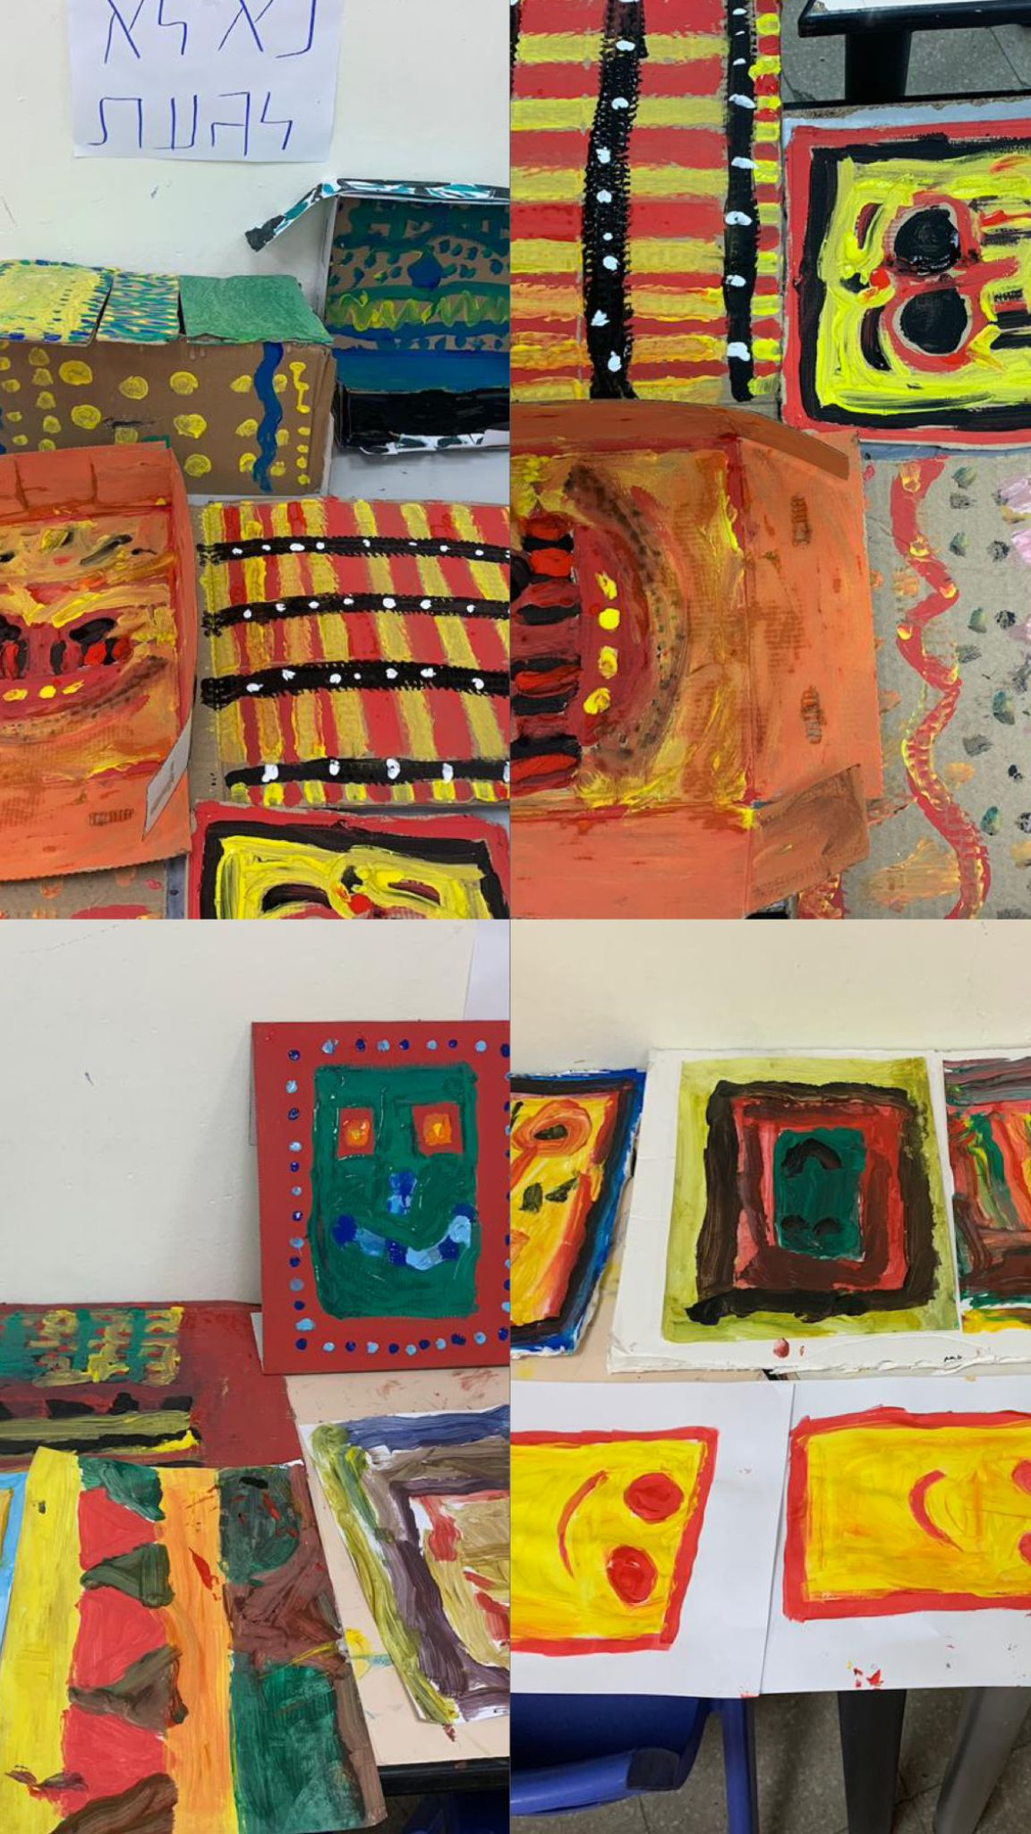

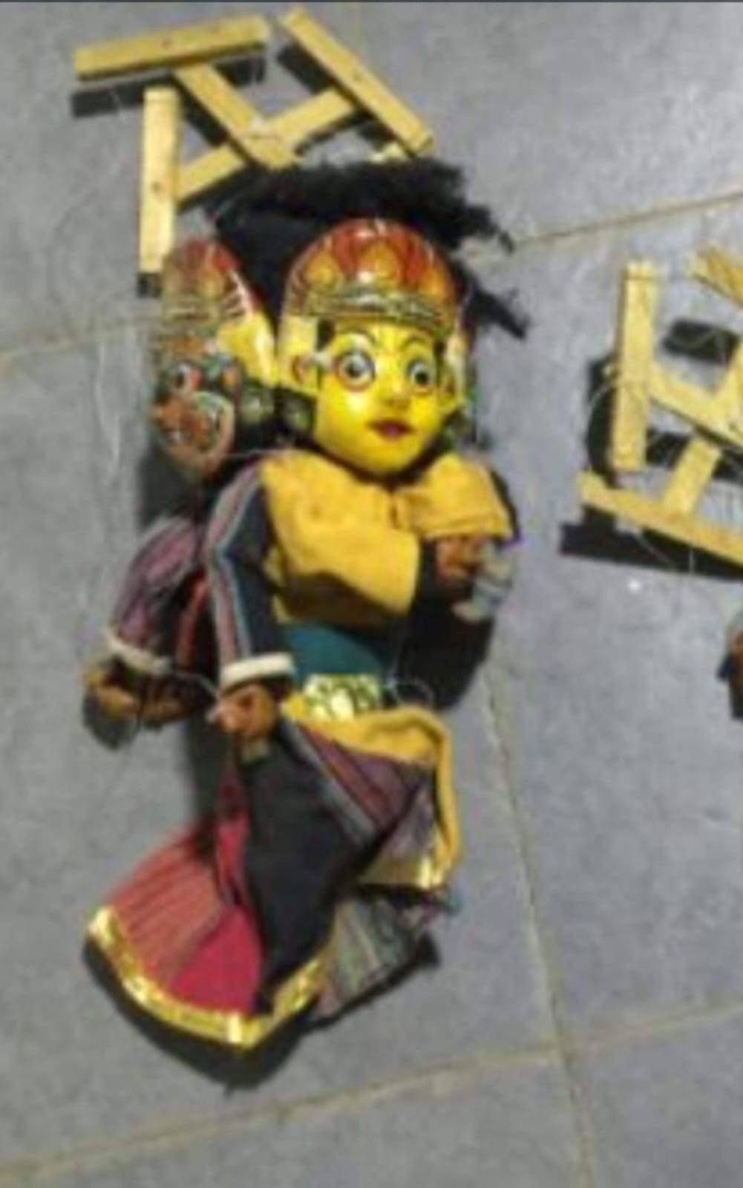

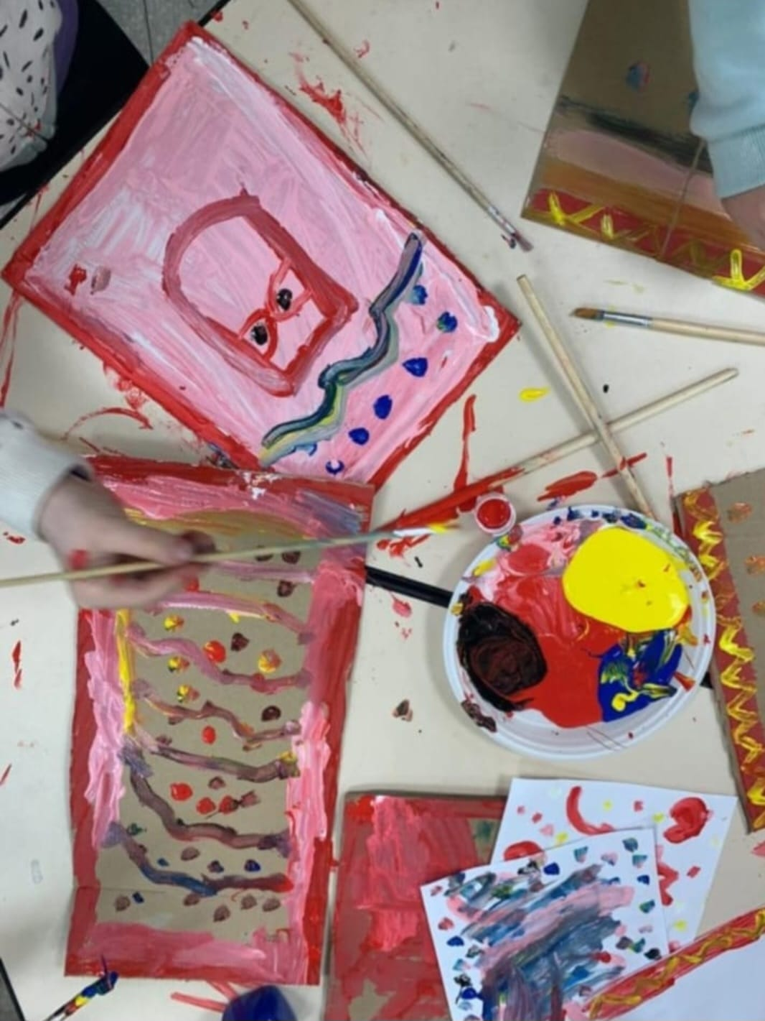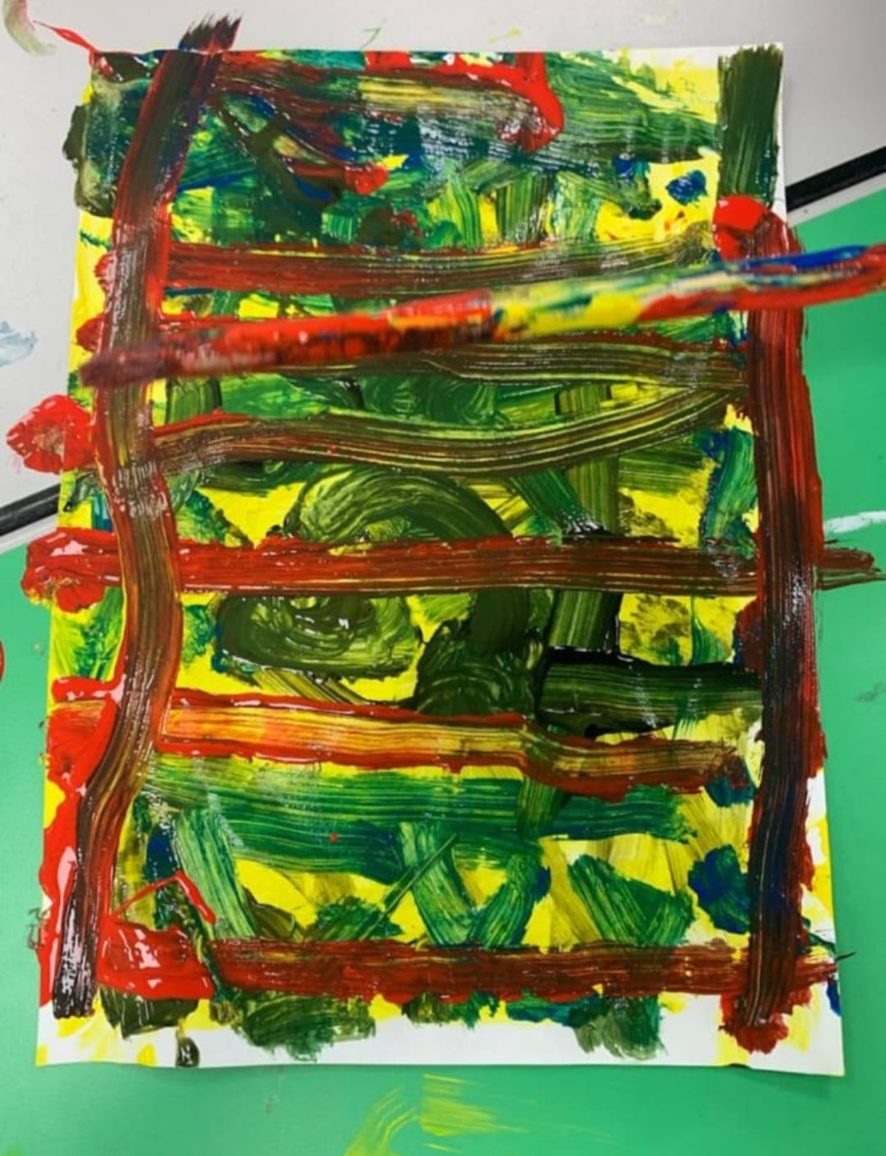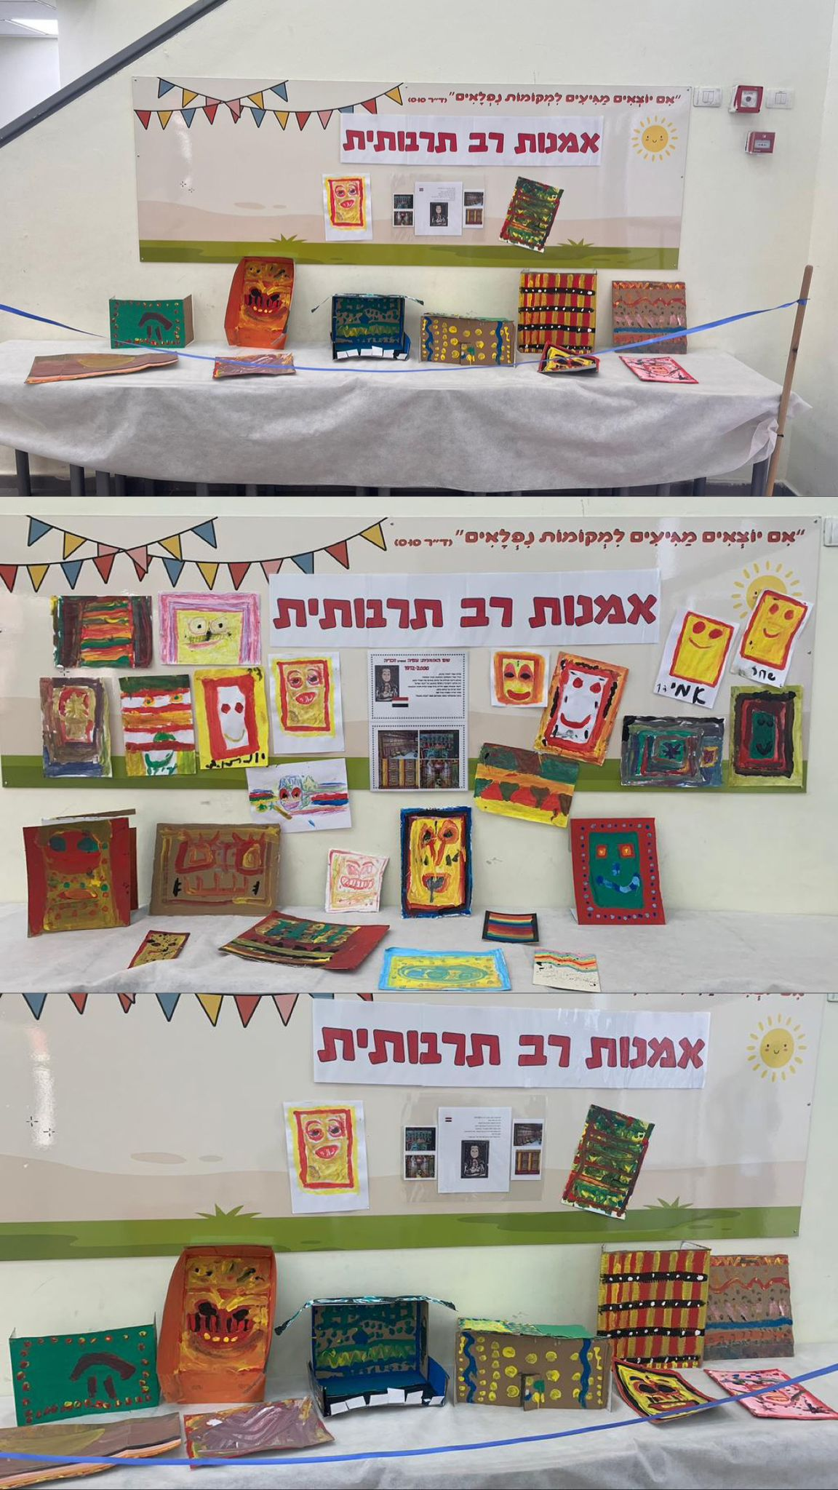

#### Afia's works

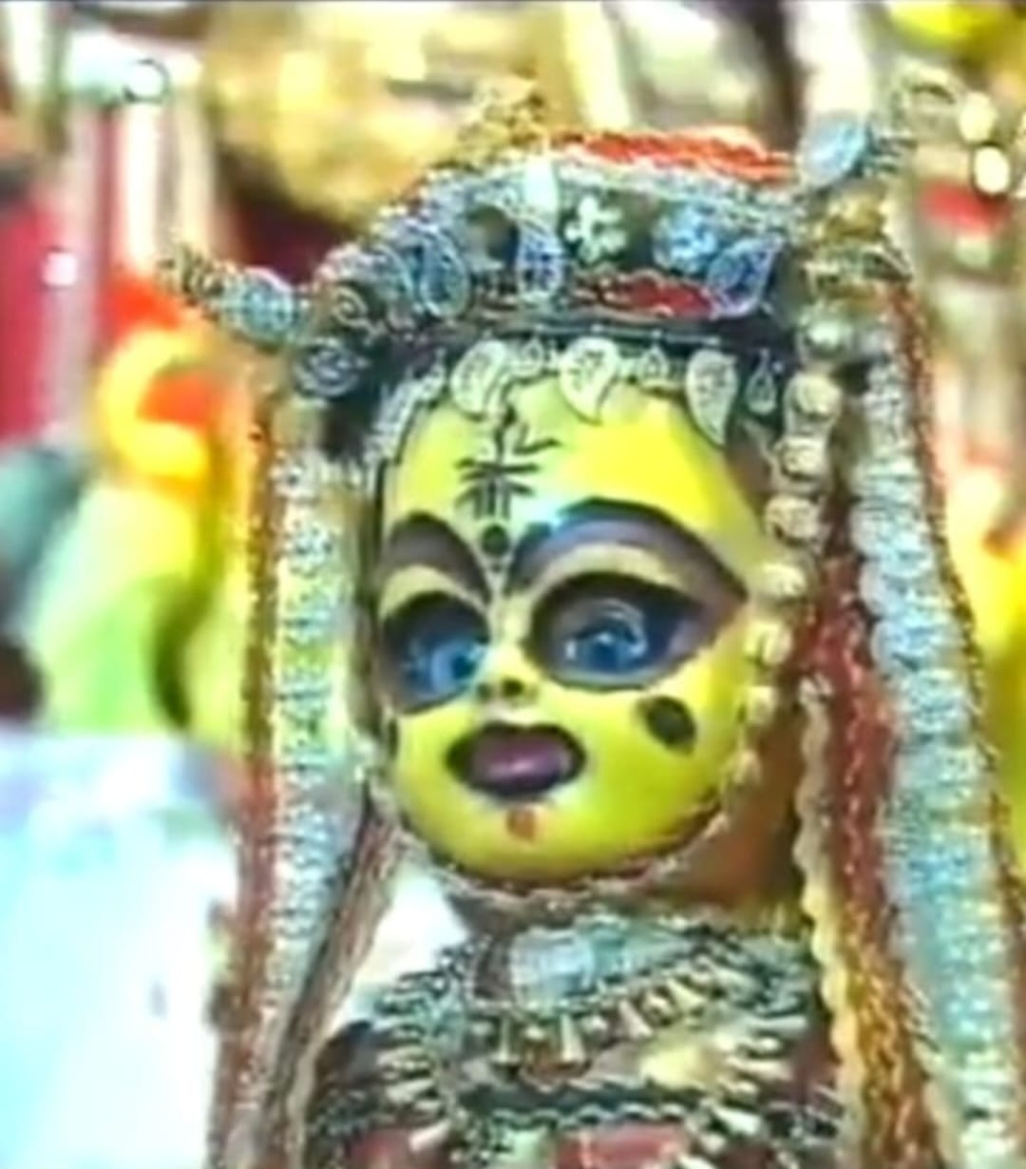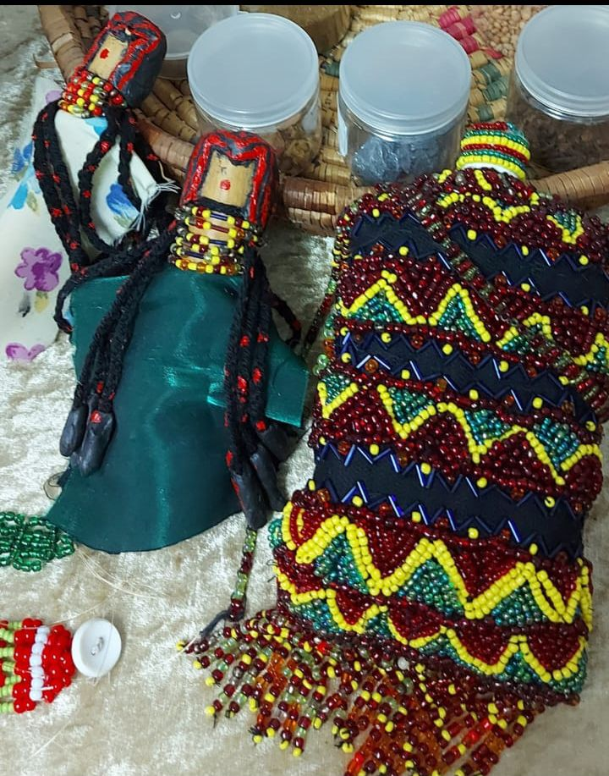

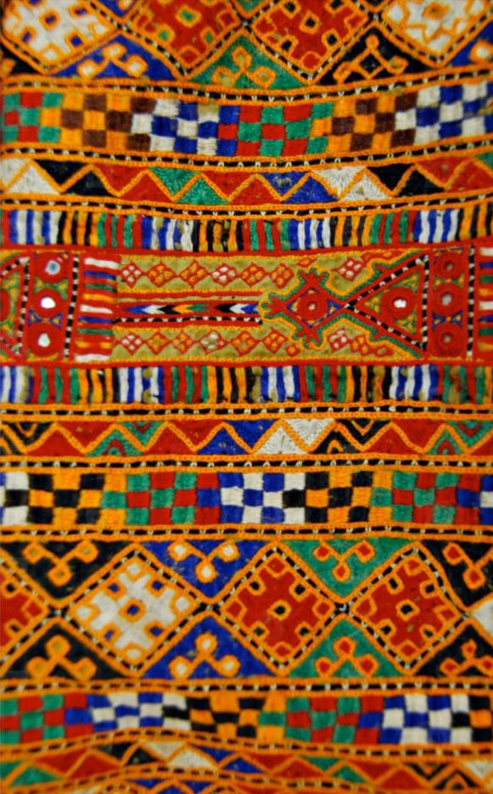

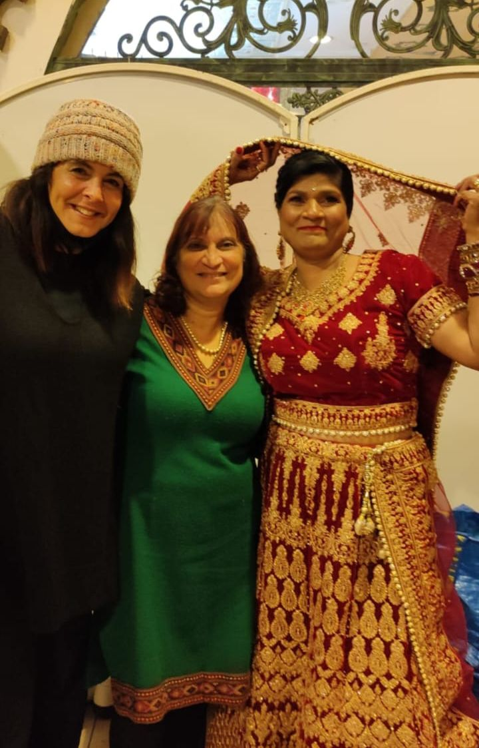

#### Pictures from Afia's life

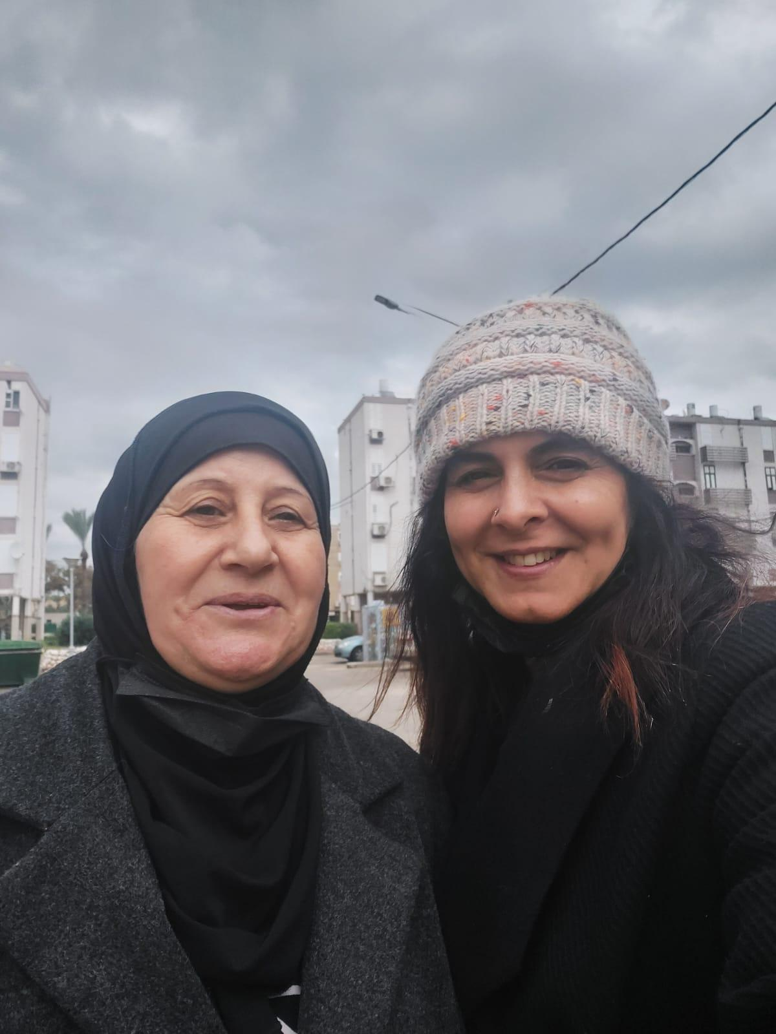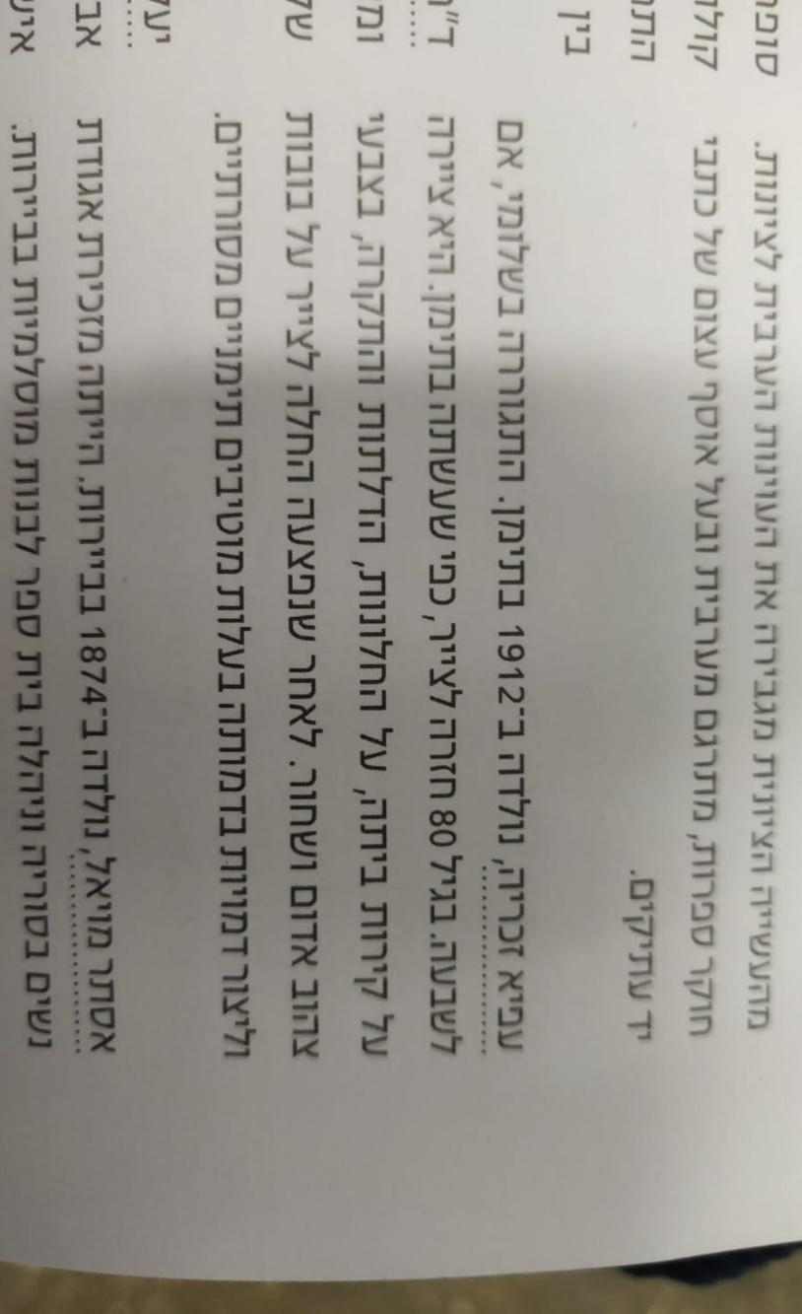

An Article in the Newspaper

1. Interview with a market vendor named Shimon, Interview Appendix No. 1.
2. Interview with Ahmad Mansour, Interview Appendix No. 2.
3. Yohanan Aharoni, *Carta Atlas of the Biblical Period*, Jerusalem: Carta Publishing, 1974, pp. 73–74
4. Shmuel Yavne’eli, *Journey to Yemen*, Tel Aviv: 5712 [1952], pp. 12–13.
5. *The Jews of Yemen: Their History and Way of Life*, Tel Aviv: Am Oved Publishing, 1967, pp. 63–64
6. Ibid., p. 78.
7. Reuven Ahroni, *The Jews of Aden*, self-published, Tel Aviv, 2007
8. Simcha Assaf, *From Egypt to Aden and India*, *Collected Essays and Studies*, Jerusalem: Mossad HaRav Kook, 1946.
9. interview with Tziona, one of the first Ethiopian immigrants to Israel.
10. Avi Picard, *The Beginning of Selective Immigration in the 1950s*, *Iyunim Bitkumat Yisrael: Studies in Zionism, the Yishuv, and the State of Israel* [1999], pp. 338–394
11. Interview with Shemesh Efrati, 2023
12. Yehuda Ratzaby, *The Exile of Mawza'*, *Sefunot*, Vol. 5, [1961].
13. Dina Harbi, *An Expert in Spongology: Housemaids and Cleaners in Hebrew Literature from the Days of Hasqin*, Tel Aviv: Gamma Publishing, 2022.
14. Matthew Hughes, “The Banality of Brutality: British Armed Forces and the Repression of the Arab Revolt in Palestine, 1936-39,” The English Historical Review 124, no. 507 (April 2009): 313–354, <https://doi.org/10.1093/ehr/cep002>.
15. Matthew Hughes, Britain’s Pacification of Palestine: The British Army, the Colonial State, and the Arab Revolt, 1936–1939 (Cambridge: Cambridge University Press, 2019), ch. 6.
16. “The 1938 al-Bassa Massacre and the Royal Ulster Rifles,” Pat Finucane Centre, accessed November 5, 2024, <https://www.patfinucanecentre.org>.
17. Hughes, Britain’s Pacification of Palestine, ch. 8.
18. Matthew Hughes, “The Practice and Theory of British Counter-Insurgency: The Histories of the Atrocities at the Palestinian Villages of al-Bassa and Halhul, 1938–39,” Small Wars & Insurgencies 20, nos. 3–4 (2009): 528–550, <https://doi.org/10.1080/09592310903027013>.
19. “British Apology Sought for Atrocities and Crimes against Palestine,” Middle East Monitor, October 7, 2022
20. Shukri Araf, *The Coastal Plain of Western Galilee in the 19th Century*, The Regional Land Studies Circle, 1973, p. 30.
21. Obadiah Bidani, from the *Intergenerational Heritage Stories Archive*, Ministry for Social Equality, 2018
22. Mazal Damari, from the *Intergenerational Heritage Stories Archive*, Ministry for Social Equality, 2015.
23. Testimony of Halima Cohen, from the book *From Yemen to Paradise in the Land of Israel*, by Moshe Cohen, Netanya: The Association for the Promotion of Society and Culture, 2021.
24. Appendices: Ibtisam
25. Appendices: Interviews.
26. Appendices: Image, Henna.
27. Miriam Rosen-Ayalon, *Islamic Art*, in *Chapters in the History of the Arabs and Islam*, edited by Hava Lazarus-Yafeh, Rosh Pina: Reshafim, 1967, p. 377.
28. Art Portal – Online Magazine, 29.1.2024
29. Book of Exodus 20:4
30. Dov Madzini, *Art*, Massada Publishing, 1981, pp. 39–40.
31. Gross and Gross, 1993
32. R. Garruci, Graffiti de Pompeii, (1856)
33. Bankruptcy, (1902)
34. Untitled, 1956, ink on paper
35. The Lost Traveler, 1956
36. Dotan, 2000.
37. The Academy of Hebrew Language - Website
38. Amos Frankenstein and Adin Steinzlitz "The Sociology of Ignorance" The Broadcasting University Library Edited by: Rachel Shihor Published by the Ministry of Defense 1987
39. Tamar Elor Grandma Didn't Know Read and Write Carmel Publishing September, 2018. Pages 288-291.
40. The Storm of Yemen, Rabbi Korach Yahya Rabbi Kook Institute Publishing Jerusalem 1954]
41. Child Marriages and Divorce Certificates in Yemenite Judaism Bar Ilan University Publishing 2020
42. Spongology Expert Housemaids and Menorahs in Hebrew Literature \Mimi Haskin\Dina Harubi Gama Publishing 2022 Tel Aviv Page 30
43. From Bracha Sari, The Hidden Light, Jerusalem, 2007
44. Yoav Ben Dov and Zahava Canaan 2004 Aviv Hadash Youth Encyclopedia Publishing Tel Aviv
45. All Rights Reserved for Civil Rights
46. (Zehr, 1990)
47. Roger Cardinal, *Outsider Art* (1972)
48. H.P. Prinzhorn, *Artistry of the Mentally Ill* (1922)
49. Marion Milner, *On Not Being Able to Paint* (1950)
50. Hal Foster, *The Return of the Real* (1996)
51. Sarah Lombardi, *Art Brut: The Origins* (2020)
52. Shmulik Jersey's lecture, Appendix No. 10
53. From an interview with Neta Lieber, Interviews Appendix No. 3.
54. Interview Appendix No. 11.
55. Israel Museum
56. Israel Museum